**KNOW IT TO WIN IT**

**by Immanuel Chiagozie Chisom Igwe**

|  |  |
| --- | --- |
| **Centre** | **St John Fisher Catholic College** |
| **Centre Number** | **303330** |
| **Candidate Number** | **9115** |
| **Qualification Code** | **7517A** |
| **Date** | **25/02/2021** |

# **TABLE OF CONTENTS**

|  |  |
| --- | --- |
| **Analysis**1.0 ………………………………………………………………………….. | 3 |
| 1.1: Introduction………………………………………………………... | 3 |
| 1.2: A Look Into Existing Systems…………………………………….. | 3 |
| 1.3: End-User Profile…………………………………………………... | 8 |
| 1.4: Overview…………………………………………………………... | 8 |
| 1.5: Limitations and Constraints……………………………………….. | 10 |
| 1.6: Data Modelling……………………………………………………. | 11 |
| 1.7: Project Objectives…………………………………………………. | 13 |
| **Design** 2.0 …………………………………………………………………………... | 16 |
| 2.1 The Registry………………………………………………………... | 16 |
| 2.2 Entering Username for the First Time……………………………... | 17 |
| 2.3 Loading the Main Menu…………………………………………… | 18 |
| 2.4 Changing the Username…………………………………………… | 19 |
| 2.5 Quit………………………………………………………………… | 20 |
| 2.6 Store………………………………………………………………... | 20 |
| 2.6.1 Displaying Coins Earned……………………………………... | 21 |
| 2.6.2 Saving Number of Earned Coins……………………………... | 22 |
| 2.6.3 Making Purchases from the Store…………………………….. | 23 |
| 2.7 Play Game…………………………………………………………. | 26 |
| 2.7.1 The Revision Mode…………………………………………… | 26 |
| 2.7.2 Quiz Mode……………………………………………………. | 28 |
| 2.7.2.1 Loading the Game Environment………………………… | 28 |
| 2.7.2.2 Displaying the Selected Avatar………………………….. | 30 |
| 2.7.2.3 Displaying the Accessories……………………………… | 31 |
| 2.7.2.4 Displaying the Questions………………………………… | 32 |
| 2.7.2.5 Moving the Avatar Across The Track…………………… | 36 |
| 2.7.2.6 Adding the Total Number of Coins and Questions……… | 37 |
| 2.7.2.7 Using Powerups…………………………………………. | 37 |
| 2.7.2.8 Pause and Restart System………………………………... | 40 |
| 2.8 Class Diagram……………………………………………………… | 42 |
| **Technical Solution** 3.0………………………………………………………………. | 44 |
| 3.1 Creating the Project File…………………………………………… | 44 |
| 3.2 Creating the Registry Class………………………………………… | 45 |
| 3.3 Coding the Start of the Program…………………………………… | 48 |
| 3.4 The Main Menu……………………………………………………. | 54 |
| 3.5 The Store…………………………………………………………… | 56 |
| 3.6 Play Game………………………………………………………….. | 68 |
| 3.6.1 Choosing the Revision Environment…………………………. | 69 |
| 3.6.2 Revision Mode………………………………………………... | 75 |
| 3.6.3 Quiz Mode……………………………………………………. | 81 |
| 3.6.3.1 Loading the Game: Explanation………………………… | 81 |
| 3.6.3.2 Selecting Random Questions: Explanation……………… | 82 |
| 3.6.3.3 Answering a Question, Moving the Avatar: Explanation… | 83 |
| 3.6.3.4 Using the Powerups: Explanation……………………….. | 84 |
| 3.6.3.5 Ending the Game, Pause & Restart System: Explanation.. | 85 |
| 3.6.3.6 Game class: Code………………………………………... | 87 |
| 3.6.3.7 Loading the Game: Code………………………………… | 91 |
| 3.6.3.8 Selecting a Random Question: Explanation……………... | 95 |
| 3.6.3.9 Determining the Answer: Code………………………….. | 100 |
| 3.6.3.10 Moving the Avatar: Code………………………………. | 104 |
| 3.6.3.11 Using Powerups: Code…………………………………. | 122 |
| 3.6.3.12 Pause and Restart System: Code……………………….. | 125 |
| **Testing** 4.0 …………………………………………………………………………… | 128 |
| **Evaluation** 5.0 ……………………………………………………………………….. | 149 |

# **ANALYSIS**

## **Introduction**

For my NEA project, I have settled with the idea of an educative game called Know It To Win It. It is meant to be like an adventure game, involving a character along a track in the middle of nowhere. The player will be asked series of questions and as they get them right, they advance forward on the track until they have reached the end.

I initially got the idea of the game after watching the 1995 movie Jumanji. In the movie, a board game was played where a user rolled two dice, and whatever number given by the dice will determine how many spaces the player’s avatar will move. As I have been trying to figure out a way to make education easier, and after finding out that students prefer playing games to doing schoolwork, why not combine both.

## **A Look Into Existing Systems**

Obviously, the educative game idea is not a new thing. There are quite a number of other educative games out there in the market. So as I was laying down my ideas for my game, I also made a search for what was out there.

As part of my research I carried out a survey on students to ask them what sort of educational they use/have used in the past. A few that were mentioned were Ducksters and My Maths. I tried these various games out and have written my report for each of them below.

### **Ducksters (**[www.ducksters.com](http://www.ducksters.com)**)**

This is an online learning platform. It is filled with different educative games ranging from different fields e.g. history, geography, science etc, with a section for educative games. There are different categories of games there e.g. math games, puzzle games, word games, sports games etc, but for the sake of the project I only looked at the math games. There were quite a number of games there, but I focused mainly on three.

* **Tronix (**[www.ducksters.com/games/tronix.php](http://www.ducksters.com/games/tronix.php)**)**

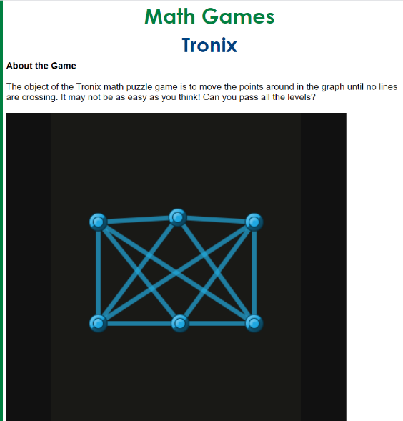

The aim of the Tronix is to move the knots in such a way that the lines do not cross each other. You can only advance to the next level if this is done.

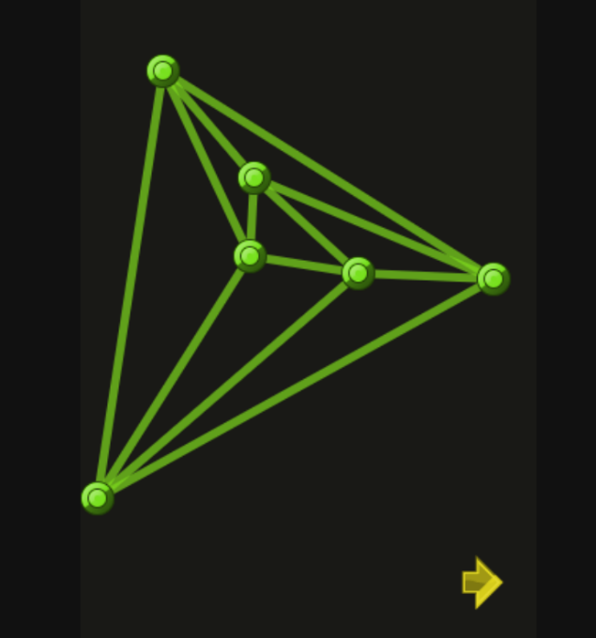

The pros of the game include that it requires some critical thinking from the player, as making sure the lines don’t cross over each other is tricky, thus helping with problem solving. Also, it provides a challenging atmosphere to the player because as the levels advance, it becomes trickier to keep the lines away from each other.

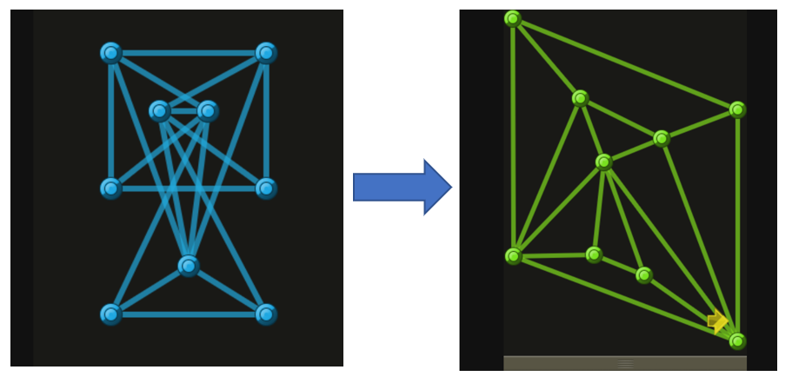

However, it does have some disadvantages which I feel should be pointed out. Firstly, there is no hint system, so when people get stuck, they have no clue to help them out. Secondly, it doesn’t really involve any maths problems that are encountered in lessons at school, so there is no reference to real maths problems that students will find difficult. This therefore doesn’t help very much to relate to real life maths situations, and is mostly for the fun purpose of it, which should be the sole intention of the game.

* **Fast Math (**[www.ducksters.com/games/fastmath.php](http://www.ducksters.com/games/fastmath.php)**)**

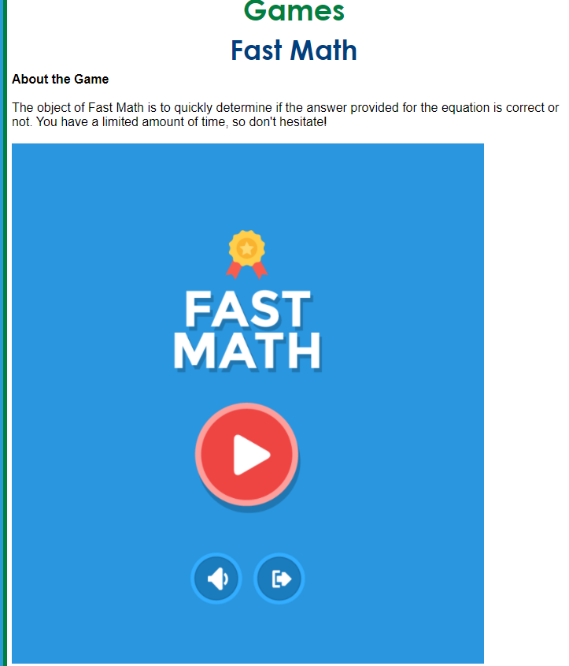

The aim of Fast Math is to answer a particular mathematical question under a short space of time. The player is given a mathematical equation, and the user is to determine whether it’s true or false quickly.

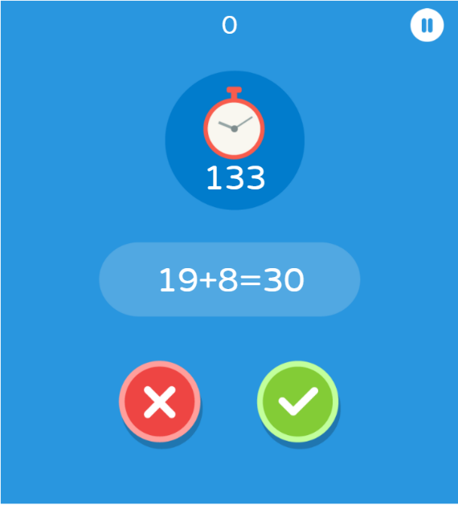

The game has quite a lot of benefits. For one, it gives the player the challenging task of quickly deciding whether an equation is true or false. This helps the player with speed and accuracy when doing maths, which is needed in a maths exam. Also, it tests a student’s ability to quickly do mental maths, as the student will have to verify the answer in their brains before they can pick an option.

However, it equally has its own downsides. The questions presented here are simple arithmetic operations, and don’t really present much of a challenge. While it helps in mental calculation, it doesn’t help so much in more technical problems in maths, which will really need help in, because these take up more questions in a maths exam than easy straightforward questions.

### **My Maths (**[www.mymaths.co.uk](http://www.mymaths.co.uk)**)**

My Maths is a very common tool for learning maths in UK. It is available for primary, secondary and sixth form, and has been very useful in remote learning during the COVID-19 lockdown. It comes in the form of a web-based app with different topics for different year groups.

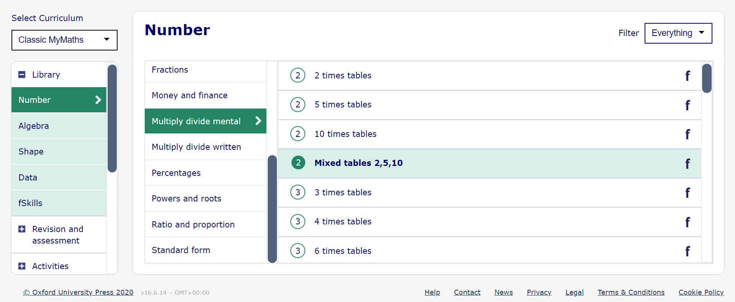

On going through the app, I discovered that most of the games it featured were mostly for younger students. I did find a few games that could/may suit older students, though they’re still mostly exercises that could be done at school and in the classroom.

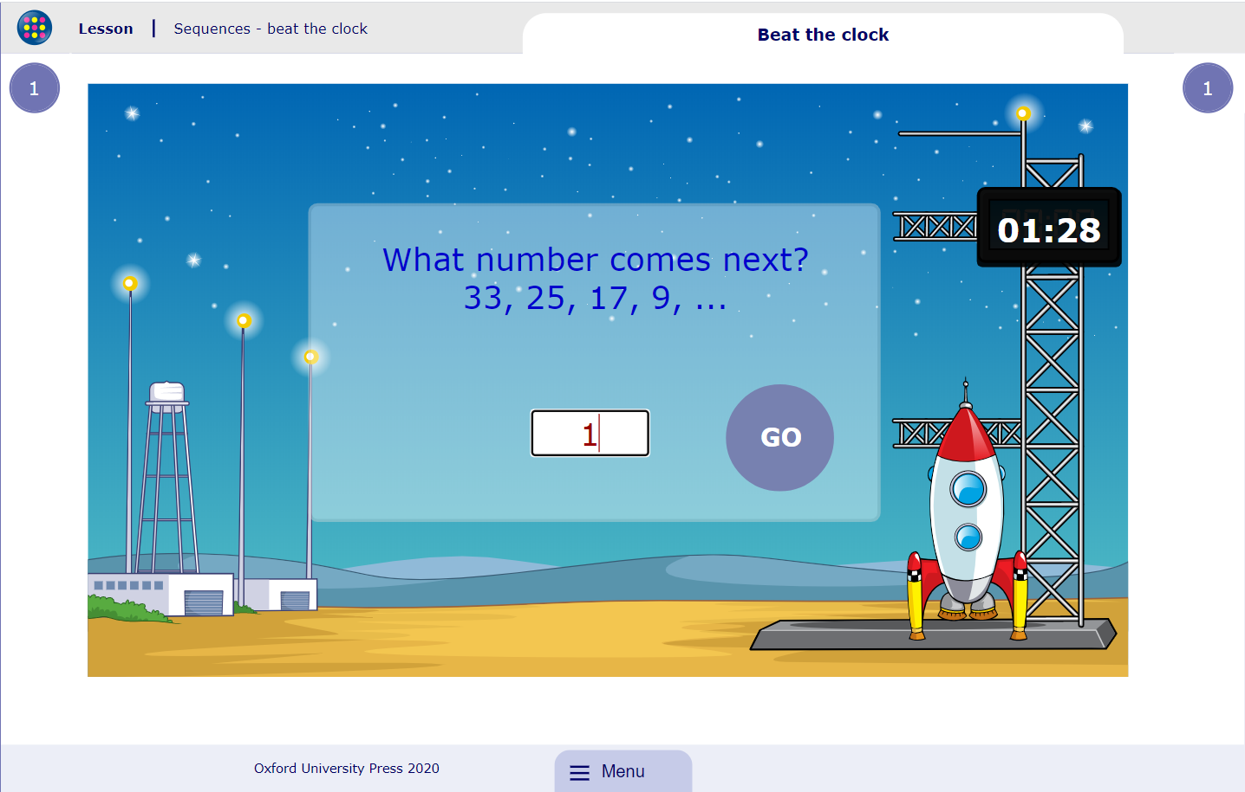

In the example above, called Beat The Clock, the user is required to put in a number to complete a given sequence, and as they advance more sequences come up, and the user is to answer as many as they can until the time runs up.

The pros of My Maths are that it contains many good resources for learning of maths, which schools are using. Its activities are mostly fun and entertaining for young pupils and students. It also provides extensive lessons for students which they can use to teach themselves maths.

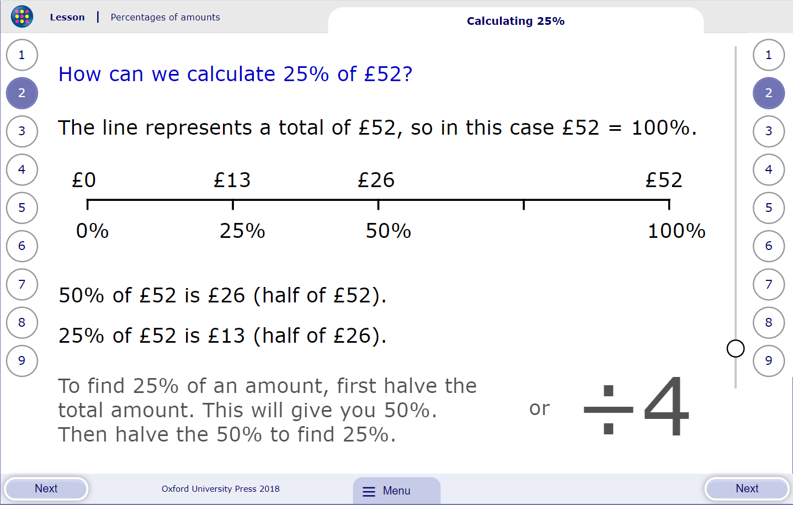

Another pro that it has is that it has exercises for students to practice their skills with, and it grades them based on their performance.

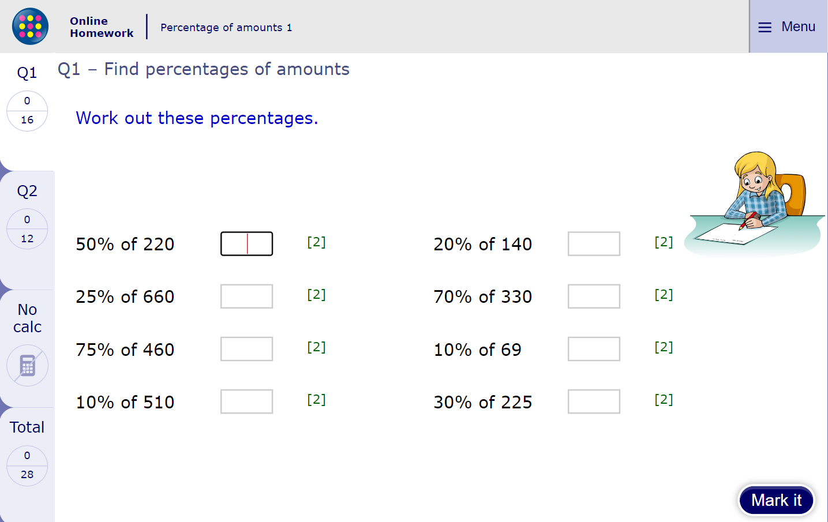

A con, that this software has, is that it doesn’t allow for a variety of answers. I personally use My Maths for A Level as I am doing A Level maths, and one thing I’ve noticed with it is that on some questions where there are multiple ways of writing an answer, it just accepts the one it wants and doesn’t go for any other way of writing, even if it’s correct. I have personally put in answers that are correct, but because it hasn’t been programmed into it as the correct answer it marks me wrong.

Another con that it has, in my opinion, is that the games in it wouldn’t appeal to older students. They may be fun for younger students, but older students, particularly those in KS4 and GCSE classes may find that the games aren’t very suitable for them.

## **End-User Profile**

When doing educative games, who you choose as your end user is very important, because there is a lot of competition in that aspect. There are many games out there for many age ranges. A lot of them have gained a massive popularity which would in turn make it difficult for new products to make it to the limelight. From my research, though, I found out that most of these games would be more fun for younger children and people who are recently starting high/secondary school.

From my personal observation, I have noticed that, in general, students do not have very positive attitudes towards schoolwork, and they prefer using their time playing games. This is particularly worrying especially amongst KS4 and GCSE students, who will be sitting their O’Level exams by the end of Year 11, and don’t have a lot of time to play around. And some of the revision material that is out there would be deemed as ‘boring’ by students, because they all involve asking and answering a question, and usually doesn’t involve much fun, because of the seriousness of the exams. And since they find playing games more pleasurable to doing “boring revision stuff”, they would prefer to do that than revise.

Also, KS4 and GCSE students sitting their O’Level exams are at one of the most important stages of their education, because how they would pass their exams would determine how they would continue their education. They will need good grades at GCSE to help them advance to A Levels, and from there university. Those who are unable to get the grades they need find it difficult progressing education wise, as it would be difficult getting into a good college or finding a good apprenticeship. However, students who are not committed to their work either don’t realize the seriousness of the situation or choose to ignore it, which would seriously affect them in time management and self-revision.

Due to these reasons, I have chosen KS4 and GSCE students to be my end users for this program. My reasoning is since students prefer playing games over revising, and as it’s a very important stage in their education which they can’t afford to miss out on, then finding a way to combine what they like doing and what they *need* to be doing would be important. So instead of just “boring” revision stuff and apps, perhaps make the revision-themed game in such a way that would be appreciated by the students.

## **Overview**

The game I intend to make will be somewhat like an adventure game. As I mentioned before, I got the initial idea for the game after seeing the 1995 Jumanji movie, and thought I’d make a game similar to the board game shown in the movie.

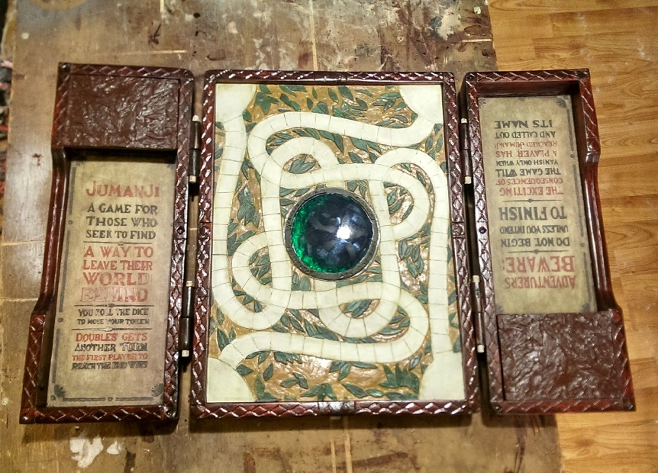

Board game from the Jumanji movie. Image gotten from

<http://boomstickcomics.com/wp-content/uploads/2017/12/Jumanji-Board.jpg>

At the first startup of the game (the first time the game is loaded), the user will be prompted to enter what they want to be their username. This is a first step to getting them to feel that this is a game.

There will then be a menu with the option of Play Game, Change Username, Store and Quit Game. On selecting Play Game, it will give them a list of subjects which they would want to revise. And on selecting the subject, there will be another menu for selecting a topic. On selecting a topic there will be another menu to select from two modes: quiz mode and revision mode. And on selecting each mode, there will be a menu on selecting difficulty levels: easy, medium, hard.

If quiz mode was selected, there will be a track with sectioned points, with an avatar at the start point of the track. Questions will come up and will be based on the difficulty level selected by the user. If the user gets a question right, their avatar moves up the track by a random number of sectioned points. If they don’t get a question right, they are given two more chances to get it right, and if they don’t, the game ends with the answer to the question displayed. Afterwards the user will be awarded with coins with a number that is the total of all the spaces they’ve moved and the sum of all the questions they got right on the first try.

If revision mode was selected, there will equally also be a track (different than the one in the quiz mode). There will be series of short tutorials based on the selected topic and as the user advances on each revision segment, their avatar will move up the track until they are done with the revision session.

The user will be earning coins as they play. The Store option in the main menu offers different powerups which could be bought with the coins the user earns. Some of the powerups will include a Hint Gem; the user can buy Hint Gems and with one they can get a hint to the question they get stuck on. Another powerup could be a Question Skipper, which they can use to skip through questions. But they will only be allowed to use 2 Question Skippers in a session. Another powerup will be the Fast Track, which basically increases the number of sections they move across the track, so meaning less questions to answer. However, this will also be rather expensive and can be used only once in a session.

## **Limitations and Constraints**

After having thought carefully about my program, its features, usage and benefits, I can say that this is definitely a very ambitious idea and proposal, and it’s definitely going to be a huge project. If implemented in the future in any way, it could change the current situation of students’ learning and revision in a positive direction. Just as there are many apps out there that have achieved something similar to this in other age and year groups, this could as well immensely help GCSE students in preparation for their exams.

However I am one person, and looking at the time frame given for the completion of the project, it will most likely be very difficult to finish it all, if not impossible. Factors affecting its completion will be firstly, it will take some complex programming skills, some of which I am yet to achieve as at the time I’m writing this. Secondly, this is something that is meant for students sitting GCSEs, and there are many subjects offered at GCSEs, and there are different topic contents across each subject. And not to mention exam boards either; different exam boards have different syllabus content for each subject, and some can extensively differ from the other. And also, I do not have much knowledge of some of the subjects and/or topics offered at GCSE, for example drama, citizenship studies, MFL etc, and for me to do a software that helps GCSE students prepare for their exams, I will need to have proper understanding of these other subjects that are offered at GCSE.

After taking all these into consideration, I have decided that for the sake of the time frame given for the project completion, I will focus on only doing maths within the game. I have chosen to focus on this subject because firstly, I’m rather good at maths. Secondly, I love doing maths. I enjoyed it while doing it at GCSE and took it further onto A Level and still enjoy doing it. And thirdly, most students I’ve met and spoken with absolutely hate maths and detest doing it. They find it rather tricky to do and can’t seem to get the hang of several techniques in maths.

In addition to focusing on only maths, I will equally only work on a few topics in the game, perhaps no more than three or four. And I will equally be using content from the EDEXCEL exam board, as this is the exam board used at my school, so it will be easier for me to understand topic content as I wouldn’t have to learn to get used to another exam board.

And as for the powerups, I will work mostly on the Hint Gems. I will see if I can perhaps do some extra work for the other powerups, but the Hint Gems will be my biggest priority.

## **Data Modelling**

After having looked into other systems and explored around with them, I have created a modelling for a few of them, to give me some idea on how their algorithms work and how to best relate them to mine.

|  |  |  |
| --- | --- | --- |
| **IPSO Modelling Chart for Fast Math** | | |
| **IPSO** | **What?** | **Evidence** |
| Input | Selection: selecting a tick or a cross for each question | Each question comes with a tick or a cross, and you select which one you think is the answer |
| Process | Check: is selected option == correct option? | Making a Boolean comparison with the selected answer by the user and the stored answer in the program |
| Process | Score: Getting the high score | It compares the score made by the user after a session with the score from their last session. It is larger, it stores it in a variable to hold the high score eg highScore |
| Process | Score: Outputting the high score | If score > highScore the value for score overwrites the value stored in highScore |
| Storage | Score | Stores the total score made by the user in the process of playing the game |
| Storage | High score | Stores the highest score ever gotten by the user in the variable highScore |
| Output | End score | After the game is ended by the user selecting a wrong option, it displays the total score made by the user in the storage section. It also displays the highest score that has been reached by the user in previous sessions of the game which would have been stored in an archive |
| Output | Continuity: next question | If the user gets the previous question right, it shows them the next question in the queue |
| Output | Timer | This displays a timer for the user to answer the question given to them |

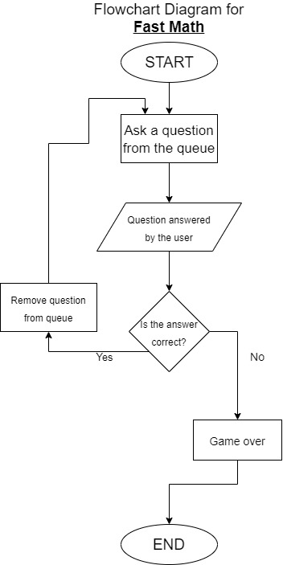

|  |  |  |
| --- | --- | --- |
| **IPSO Modelling Chart for Beat The Clock (Game from My Maths)** | | |
| **IPSO** | **What?** | **Evidence** |
| Input | Typing in an answer | The user is required to enter an answer to a question |
| Process | Check: is userInput == storedAnswer | Making a Boolean comparison with the entered answer by the user and the stored answer in the program |
| Process | Check: is timer over? | If the time isn’t up then the program keeps running |
| Process | Score: displaying the user’s performance | It processes the number of questions from the queue that the user has answered and how many they got |
| Storage | Number of questions | Stores the number of questions the user has attempted |
| Storage | Questions answered correctly | Stores the number of questions the user has attempted correctly |
| Output | End score | Displays the user’s end performance. It shows them the number of questions they’ve gotten correctly in relation to number of questions asked eg “You got 5 out of 7 questions” |
| Output | Timer | This displays a timer for the user to answer the question given to them |

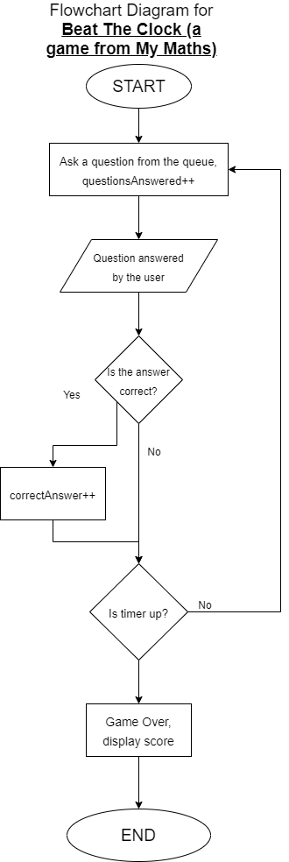

## **Project Objectives**

While carrying out my research, I made a survey and asked a few of my friends who are within the members of my target audience to fill in the survey.



One of my questions asked is they played games. Two-thirds of the people who answered (blue) said yes, while the remaining (orange) said no. From this, it shows that my intention of creating a game would most likely reach out to a lot of students as they liked playing games.

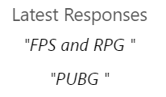

In another question, I asked what kind of games they played. Since my intention is to make a game that students would connect to, I had to know what sorts of games were played by those who did play games.

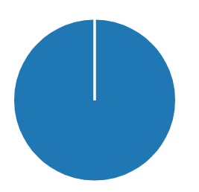

In another question I asked who would like to play an educational game. Everyone who filled in the survey said they would like to play an educational game. From this result, it could be said that students would want a game to play that would help with their education, which could show that there isn’t much available to making revision more fun and enjoyable.

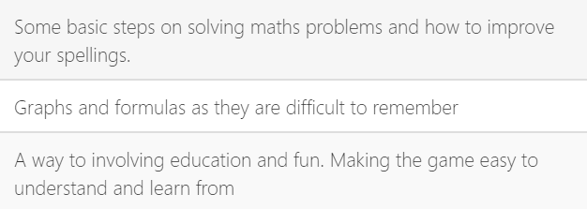

My final question was what they would expect to see in a revision game. Looking at the answers provided, most of them tend more towards helping to understand maths better, which is my main focus while creating this project. This as well draws the conclusion that students find maths hard and difficult to grasp.

From all the research that has been carried out and after some careful consideration, the following are my objectives for my project:

1. First, to create a menu.
2. The menu should have the following options: Play Game, Store, Change Username and Quit
3. When the user selects Play Game, it should lead to another sub-menu where they can select a subject. For the sake of the project though, only maths will be available.
4. On selecting their preferred subject, it then leads to another sub-menu where the user selects their preferred topic. For the project I will do no more than four topics.
5. On selecting their preferred topic, it then takes them to another sub-menu where the user will then select their preferred learning mode: quiz mode or revision mode.
6. For revision mode, the topic will be broken down into simpler sections. From the survey I carried out, students requested a way to make stuff easier to understand and remember. So these are the following things I’m considering doing:
7. I would look at doing at having a flashcards system in the revision. This would quickly go through the most important parts of the lessons, and also the bits that students find difficult to grasp.
8. For quiz mode, it then launches the main game system. As I have described earlier, it will feature a track with an avatar chosen by the user. Questions then appear and the user answers them. For every question the user answers correctly, they move up the track a random number of times. These are what I plan to achieve in the making of the game:
9. Questions will be multiple choice questions, where the user will be required to select an answer. There will be a hint button available if the user has purchased a Hint Gem from the store. There could also be a few questions which will be partly solved and requiring the user to fill in blanks to complete them.
10. The avatar should move up the track a random number of times once a question has been answered correctly.
11. There should be another box by the other side in the window that shows you the number of powerups that you have.
12. There should be a pause/resume system, a restart game process and an end-game process in the game.
13. When the game finishes, it should display the user’s performance, showing the number of questions they answered correctly and the ones they failed, and the number of powerups they used. It will also then show them the number of coins they’ve earned, which will be the total of all the spaces they’ve moved and 2 multiplied by the sum of all the questions they got right on the first try.
14. When the Store is opened, it displays the total coins that the user has earned throughout playing the game.
15. There should be a box displaying the total number of coins earned by the player through the course of playing the game.
16. There should be another box showing the powerups purchased by the user.
17. The available powerups will be displayed along with their prices and the purchase option. When the option is selected, if the user has enough coins, they equip it.
18. There will be different avatars which will come with their different prices as well, along with a default, which is the original avatar. As the user earns coins, they can buy other avatars and equip them as well.
19. In the Change Username, the user will be able to change their game username if they so wish. From the survey carried out students said they played RPG, FPS and PUBG, and usually PC games require the player having a username. Even though the game is not intended to be a tournament sort of game with a leaderboard and so on, but with the players having a username, it will in a way make the game more appeaseable to the students.

# **DESIGN**

After listing out the things I would like to achieve in the making of this project, the next step is to model them.

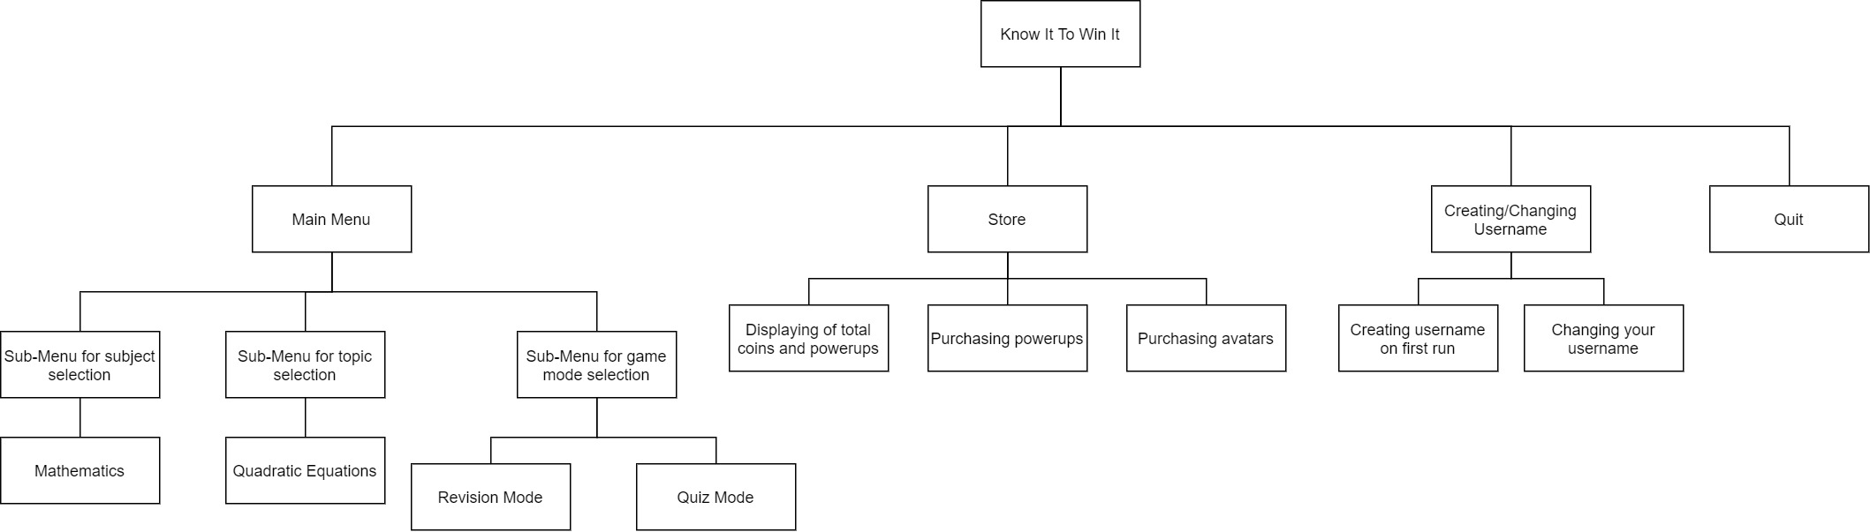Before doing all that though, I have first of all designed a top-down diagram of the entire system, showing the different tasks that will be encompassed into the system.

Most of the work is going to be involved in the Play Game and Store tasks, as these are the main parts of the system. I have started developing designs for what each of the tasks will do, although these may change through the course of developing the system.

For my project, I will be using C# Windows Forms. I chose this because firstly, I have been learning the C# programming language at school since I began sixth form, and it is the programming language I am very conversant with. I have also chosen C# because it enables object oriented programming, which I will be using heavily in this project. I will be using Windows Forms because it gives me a graphic interface which enables me to interact better with my objects. I am also using Windows Forms because it is generally easier to code in it than in Console mode for a project of this calibre.

## **The Registry**

On making some research into my program, I have found that I will need to have a system by which I can store values outside of the program, and those values will need to be available even after the program has been closed. I can’t use regular variables because these are stored only in the RAM, and once the program has been closed values stored in the variables will be wiped out. So I will need to find a way to save these values outside of the program, and these values will need to be able to be rewritten to and fetched.

A way that I considered going about this was the use of file handling. I was initially planning on saving the stored into text files, and then fetch the values from the text files and overwrite the values in those text files when new values were needed to be stored. However, using text files would be significantly risky. Unless specifying a storage directory, the text files are stored by default in the Debug folder of the program. But if the program were to be, for instance, downloaded and installed on an end-user machine, there wouldn’t be a Debug folder for the text files to be saved, which could lead the program to crash as there is no specified file directory for the program to be saved. And if a file directory were to be specified, the chances of the user finding the text files and tampering with them are high, which could lead to a malfunctioning of the program.

After doing some research into this, I found out another and better way to go about storing values outside of the program. This was the registry, which is a hierarchical database system in the Windows OS which enables programs to store files and values which would later be read from and written into by the program itself. This makes it easier to keep the values safe and out of reach from the user.

## **Entering Username for the First Time**

On the very first time of loading the program, the user will be prompted to enter their first username. What happens here is that first of all, the program reads if there is a stored username in the registry. For there to be a stored value that means the registry directory would have already been created with the username stored in it. If the directory doesn’t exist, then it is created, and the user is then prompted to enter a username, which is then stored in the registry. Then the main program then loads.

ENTERING USERNAME

CHECK Registry

IF (USERNAME.exists == false)

MessageBox.appear

print(“Enter your preferred username:”)

username ← USERINPUT

STORE username IN registry UNDER key USERNAME

MessageBox.close

ENDIF

Menu.load

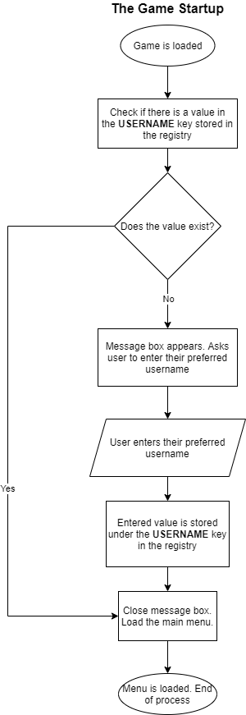

## **Loading the Main Menu**

After entering their username, the main menu of the game will be loaded. This is actually the first thing that will happen once the program is started, and then if it’s the first time of loading, the prompt to enter their preferred username would then come up.

I have created a basic design for the main menu. It basically consists of a backdrop of a forest, with the name of the game **KNOW IT TO WIN IT** boldly displayed at the top centre, with a teaser text below it that says “***do you have enough knowledge to escape the forest?***”, or perhaps something better as soon as I can think of it. There will be four buttons; the **Play Game**, the **Store**, the **Change Username** and **Quit**. Each button will have a tooltip which would briefly display what each button is about.

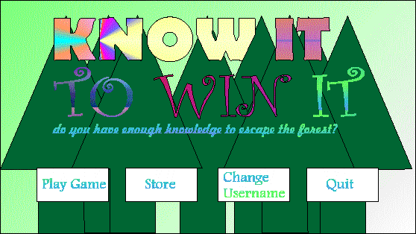

My design for the main menu. This may change in the course of creating the program.

The **Change Username** and **Quit** options are going to be the easiest and smallest bits of the program, so I will discuss these bits first and just get them over with.

## **Changing the Username**

Once the **Change Username** button on the menu has been clicked, it will load a dialog box which will have a text which says “**Enter your current username**”, and a textbox for the user to enter their current username. Then there is a button “**Done**” which the user will click after entering their username.

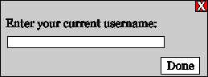

If the username entered is not the current username, the system will prompt them that it is not correct, after which they’ll have to try again. After the user has entered the right username, they’ll then required to enter their new username. Afterwards they can click on “**Done**” and the dialog box will close, with their username changed.

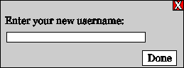

If along the way they decided to change their mind and not change their username, they can close the dialog box straight away, and there will be no changes made to their username.

As their username has been updated, it needs to reflect in the value stored in the registry. To go about this, I’m basically to write their new username into the **USERNAME** key already created in the registry. This will overwrite any already existing names inserted there in the past, and anytime the username is fetched from the registry, the newly inserted name will be used.

Below is the flowchart and the pseudocode for this:

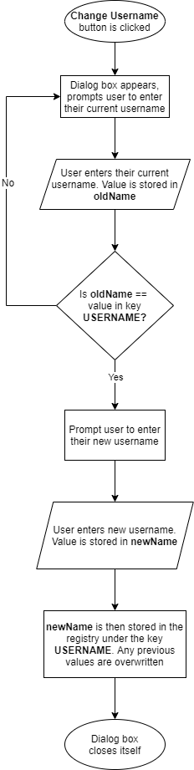

CHANGE USERNAME

MessageBox.appear

print(“Enter your old username:”)

oldName ← USERINPUT

IF (oldName == USERNAME)

print(“Enter your new username:”)

newName ← USERINPUT

STORE newName INTO registry with key USERNAME

MessageBox.close

ELSE

print(“Incorrect, please try again:”)

ENDIF

## **Quit**

On clicking the **Quit** button, this closes the entire program. I’m still contemplating on whether I should add a dialog box saying “**See you soon!**” or a similar message, or if the program should just close straight away. This is a very simple algorithm to do so I might as well perhaps go ahead and do the dialog box.

## **Store**

The Store is the second largest part of the program. Just like in other games, the store will contain all the powerups for the game to enhance it, as well as other avatars. Each powerup and avatar come at a price of a certain number of coins, and the user will only be able to buy and equip the powerups if they have enough coins to purchase them. These coins would have been earned during the course of playing the game, and the total number of coins the user has earned in the course of playing the game will be displayed in the store as well.

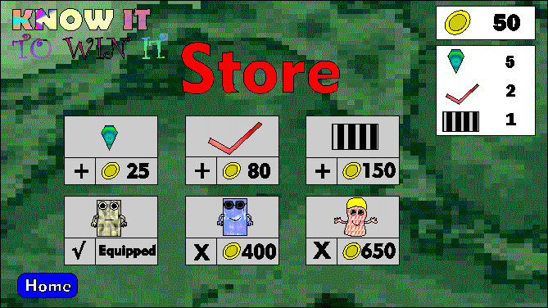

My design for the Store. This may change in the course of creating the program.

The design for the store basically consists of a strong green backdrop, which serves as reference to the jungle. The title of the program **KNOW IT TO WIN IT** will be displayed by the top side, made inferior, with a larger text “**Store**” displayed at the top of the window. By the opposite side to the title text will be where the total number of coins and number of equipped powerups will be displayed. They will be enclosed in a box, a separate box for the number of coins and a separate box for the equipped powerups, with the one with the coins on top.

In the centre of the screen will be the powerups and avatars. There will be two rows, with the powerups on the top and the avatars on the bottom. Each powerup will have its price next to it, along with a “**+**” button. The button is meant to add the powerups.

On the bottom row are the avatars. There will be a default avatar which is already equipped, and will have the “**√**” symbol next to it, to show it has been equipped. The other avatars will have an “**X**” next to them along with their prices. The “**X**” shows that they have not been purchases. Once purchased, they will be equipped, and the previous avatar that was equipped will be marked with an “**X**”, and a text which says “**Purchased**”.

### **Displaying Number of Coins Earned**

Displaying the total number of coins the user has earned is going to give me the same issue as storing their username, and in a more complicated way. As the user plays the game, the value of the coins earned will be changing constantly. Not to mention what would happen if the program were to be closed. If I were to store the total number of coins in a variable, once the program is closed all values will be lost.

So solve this problem, I will equally be using the registry to store the value of coins earned as the game is played. When the store is loaded, the value stored in the registry for the total number of coins will be displayed. If there has been any purchase made while the store is open, the number of coins spent will be subtracted from the total, and then the value of coins displayed will now change to the amount that is remaining.

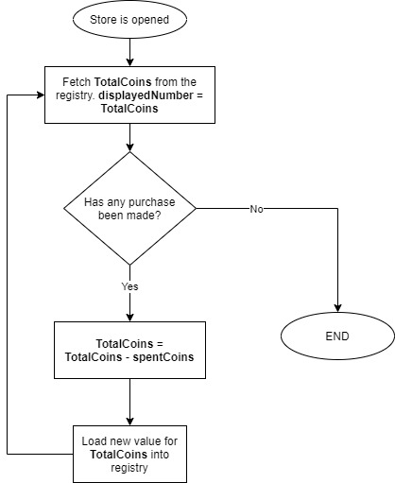

### **Saving Number of Coins Earned in a Game**

As the user continually plays the game, they will be earning more coins. So after each game has been played, the user will have earned some amount of coins which will add to the ones they already have. We would also want to keep this value safe as the user would have worked hard to get these coins, and they wouldn’t want to lose them so easily.

How I have decided to do this is that during the course of the game, there will be a variable **coinsScored**, which will hold all the coins that the user has earned. In every correct question, a particular number of coins will be added to **coinsScored**. When that session is over, the value of **TotalCoins** will be fetched from the registry. Then **TotalCoins** = **TotalCoins** + **coinsScored**. The new value of **TotalCoins** will then be saved to the registry.

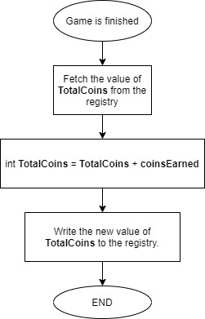

### **Making A Purchase From The Store**

Just as in other games, for you to be able to purchase items from the store, you need to have enough coins to purchase one. These coins will consist of all the coins the user would have earned in the course of playing the game.

Each of the items have been given their different prices. I have thought of three different powerups and avatars that can be equipped by the user. My powerups and their prices are namely:

1. Hint Gem: 25 coins
2. Question Skipper: 80 coins
3. Fast Track: 150 coins

My avatars and their prices are:

1. Casual Player: equipped by default
2. Kool Kid: 400 coins
3. Fun Guy: 650 coins

(The names and prices of these powerups and avatars may change in the course of making the program)

Each of these powerups have a set price in the program. I will set them as constant variables in the program, so that they can not be changed. I am not storing these into the registry since they are fixed values and are not going to be changed, so as to save memory for other values that will change. The ones that will go into the registry, though, will be the number of powerups the user has obtained and the purchased avatars by the user. When a user purchases a powerup, the value of the total number of that powerup they have purchaserd will be save to the registry. Their total numbers of coins will subsequently reduce based on how much they’ve spent for the powerup(s). And when they’ve used up a powerups, the number of powerups they’ve obtained will subsequently go down.

When it comes to the avatars, it will be a slightly different situation. The avatars are the characters that represent the user while playing the game, so therefore you can’t buy two of the same avatar. So instead, when an avatar has been purchased, it will change a boolean set for the specific avatar to **true** from **false**. So basically, each avatar will have **avatarPurchased** and **avatarEquipped** characteristics, which are by default set to false, except for the Casual Player, which is by default true. When the user purchases an avatar, then **avatarPurchased** = **true**, with **avatarEquipped** still set to false. If the avatar has been equipped, then **avatarEquipped** for that avatar is set to **true**, with **avatarEquipped** for all the others set to **false**. This bit will require some rather decisive programming to avoid clashes with other powerups and avatars.

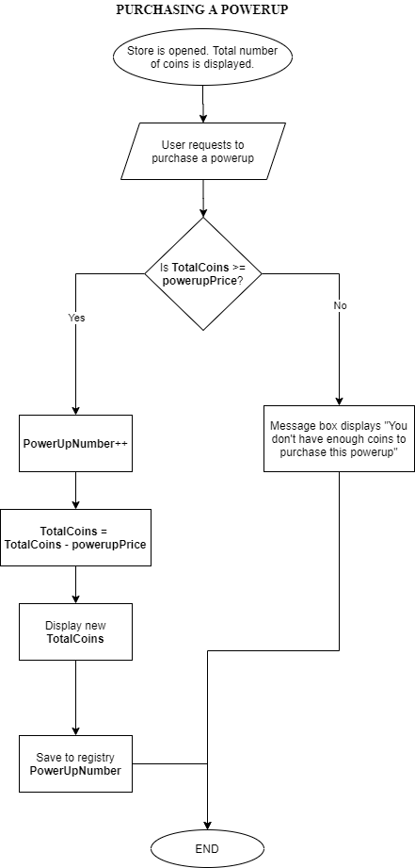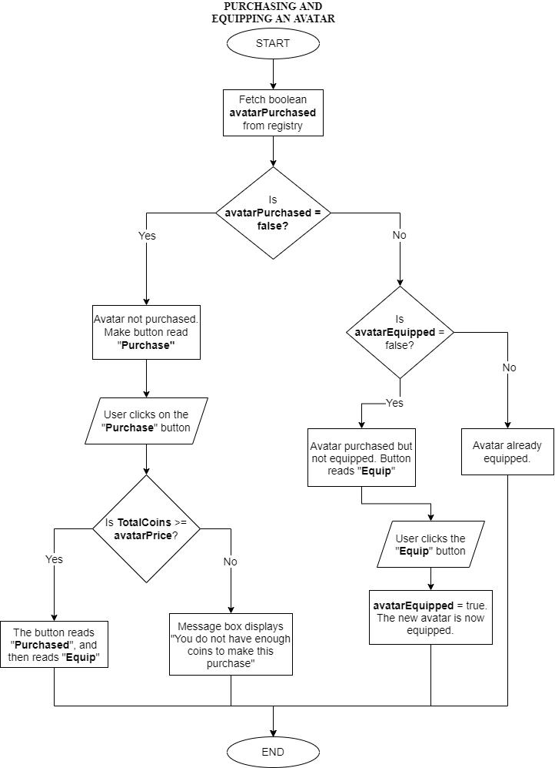

## **Play Game**

The Game is perhaps the largest bit of my program, which is where most of my time will be spent in the making of this project.

From my already laid out objectives, after the “**Play Game**” button has been clicked, there will be a submenu which will ask the user to select their subject. Afterwards, another submenu will appear asking to select their preferred topic. Afterwards they would be asked to select their preferred learning mode.

For the sake of the project, I will be doing only the following:

1. **Subjects:** Maths
2. **Topics:** No more then 4
3. **Learning Mode:** Revision Mode and Quiz Mode

I will have a class called “Game” within my code, which will contain the elements needed for the game. There will be the variables **selectedSubject**, **selectedTopic** and **selectedMode**. When anything has been selected, it will assign an appropriate value to each variable which will help me in selection programming in my code. I will be using string values to identify these selections.

### **The Revision Mode**

If Revision Mode has been selected, the user will be taken to a new window. The window will have a brown backdrop, and there will be a picture box in the middle of the screen, and a Home button at the lower left end of the window. I intend to do a flashcard system for each topic, with there being different cards for different aspects of the topics. The picture box will be used to display each card. Below the picture box will be Forward and Back buttons in the shape of arrows. The Forward arrow will be by the bottom right of the picture box, and the Back arrow button will be on the bottom left of the picture box. The “Back” button will be disabled for the first slide and the “Forward” button will be disabled for the last slide, so as to let the user know that they’re either at the beginning or the end.

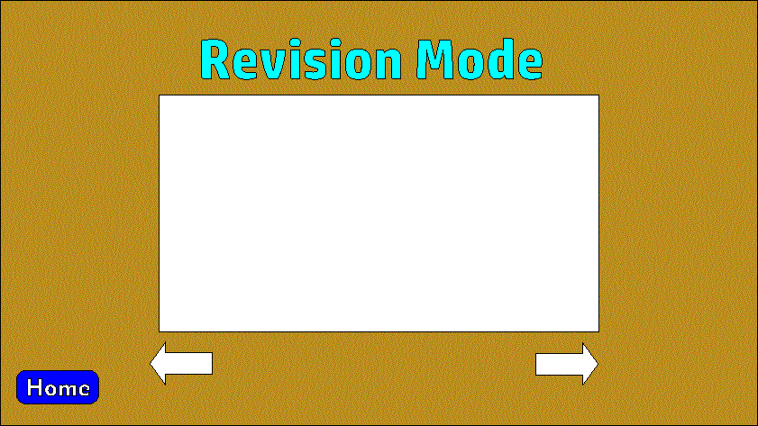

The Revision Mode window

There will be preset number of slides **slideNumber** for each topic, and there will be a counter **slideCount**, so whenever the “Forward” button is clicked, 1 will be added to the counter until it is equal to the **slideNumber**, at when the “Forward” button will be disabled. Similarly, when the “Back” button is clicked, 1 will be subtracted from **slideCount** until it is equal to 1 (the starting point), at when the “Back” button will be disabled.

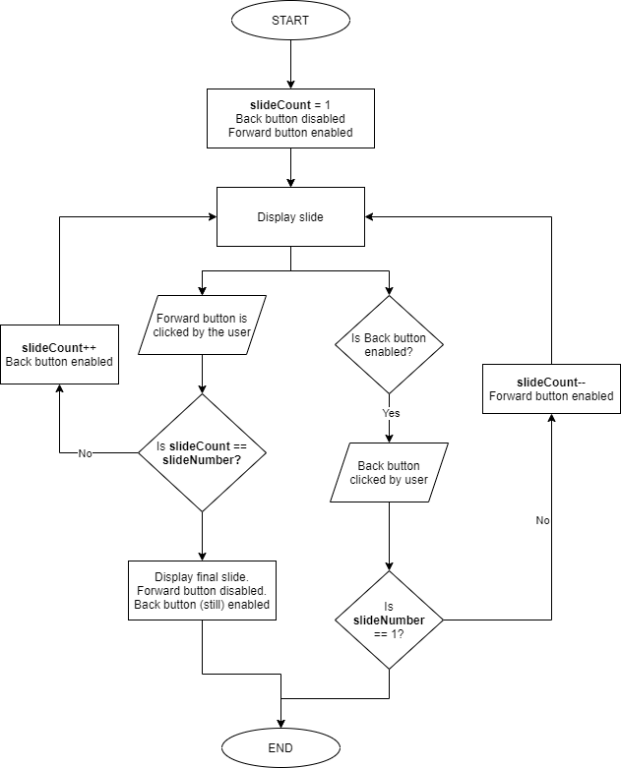

### **The Quiz Mode**

This is the main game of the system.

Once the Quiz Mode has been selected, a lot of processes are going to take place during the game. I have broken this down into separate segments of the different bits and pieces.

The first bit will be the loading of the environment.

#### **Loading the Game Environment**

As I have mentioned earlier on in my project, my game will be similar to the game board featured in the 1995 Jumanji movie. In my game, it will feature a track on which the selected avatar chosen by the user will move across from the beginning to the end. Questions will randomly appear and if the user gets a question correct, their avatar will move up on the track a random number of times.

I intend to have a collection of different tracks, and one will be randomly selected when the window loads. Each of these different tracks will come with different orientations and shapes. I want to create this varierty so that the game will be more appeasable to the user and it wouldn’t be the same old boring thing over and over again.

Below are a few drafts for possible tracks I intend to use:

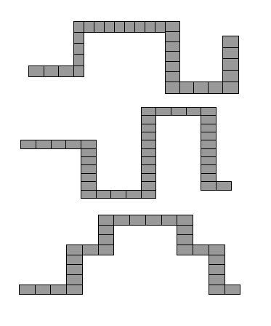

Track drafts I intend to use

There will probably be about 5 different tracks, which will be selected at random when the game is loaded. The tracks will be on a green foresty background, with the selected avatar moving along the cells on the track.

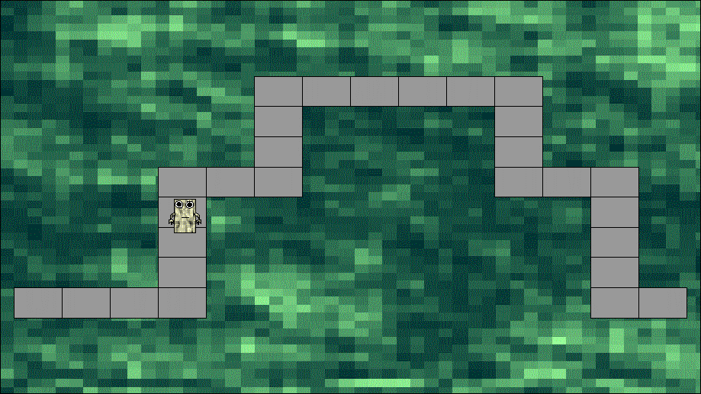

A sample of an avatar moving along the track in the game environment

#### **Displaying the Selected Avatar**

When the game is loading, the avatar that has been equipped by the user will be the one displayed. By default, the avatar is the Casual Player, unless the user has purchased and equipped a different avatar.

In order to do this, I will have a picture box which will show the avatar selected. The program will fetch from the registry whether these avatars have been equipped or not. If **avatarEquipped** is true, then whichever avatar that has been equipped will be displayed by the picture box.

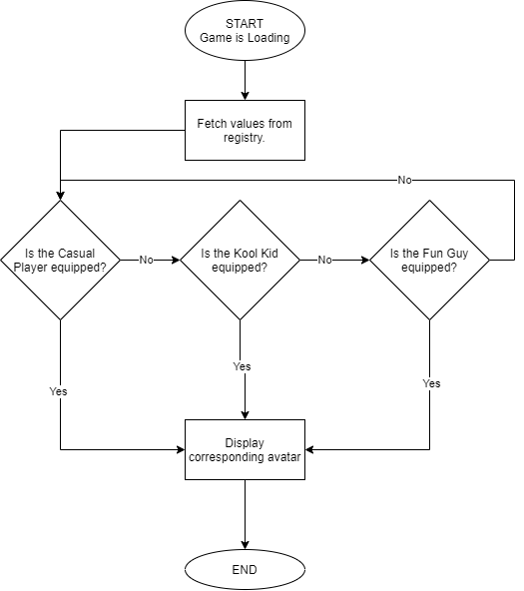

These are stored in boolean values, in which one has to be true. Not more than one is true, and not less or more than 2 will be false.

#### **Displaying the Accessories**

The game accessories are the purchased powerups from the store. The number that the user has purchased will be displayed as the game loads.

Basically, the saved total values of each powerup will be fetched from the registry and displayed. The values will be situated in the right hand top corner of the window, beside their respective icons, similar to the way they’re displayed in the store.

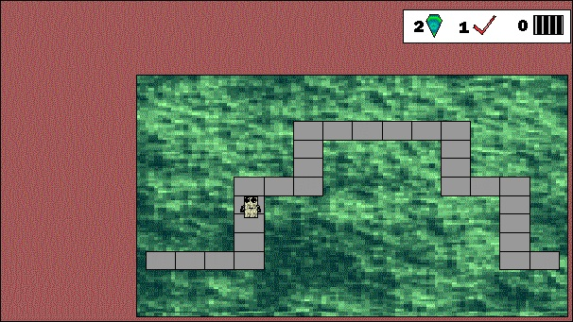

Displaying the game accessories

DISPLAYING THE GAME ACCESSORIES

Program starts

hintNumber ← Registry.HintGemNumber #Hint Gems

skipNumber ← Registry.QuestionSkipperNumber #Question Skippers

trackNumber ← Registry.FastTrackNumber #Fast Track total

OUTPUT(hintNumber)

OUTPUT(skipNumber)

OUTPUT(trackNumber)

#### **Displaying the Questions**

By the left side of the window, the questions will be displayed. For each topic, there will be anything from 20 questions and more. Some of these I will fetch from past questions, and some others I could make myself. In each game session, about 10 questions will be asked, and these questions will be selected at random, with no question repeating itself.

To ensure none of the questions repeat themselves, I will have a list containing the numbers 1-20. There will be a question counter which will not exceed 10 (the total number of questions for the user to answer) within a loop, and in each loop, a random number is generated. The question number will be displayed and that number will be removed from the list, so that if the random number is generated again and it is not found in the list, it will generate another random number again.

For instance, if the number 5 were to be randomly generated, it will check if the number exists in the list. If it does, then question 5 will be displayed, and then the number 5 removed from the list. That way, if the question 5 were to be generated again and the number 5 doesn’t exist in the list, it will generate another random number, and not proceed to display question 5 again.

DISPLAYING A RANDOM QUESTION

questionList ← [1, 2...19, 20]

questionCount ← 0

WHILE questionCount <= 10

randomQuestion ← RandomNumber(1, 21)

#generating a random number between 1 and 20

IF questionList.Contains(randomQuestion)

questionList.Remove(randomQuestion)

DisplayQuestion(randomQuestion)

#calls the routine to display the question

questionCount++

ENDIF

ENDWHILE

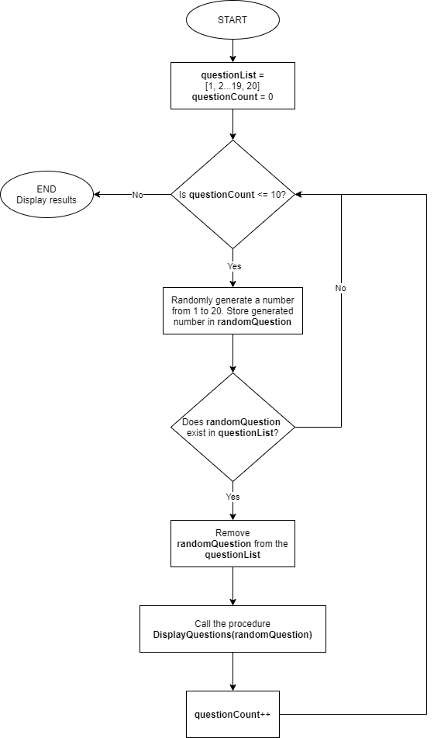

Below each question, there will be a button by the bottom right next to question. The button will read “Done”. The user will click the button when they’re done answering the question. If they’ve gotten the question right then they can proceed to the next question, but if they haven’t then they’ll be allowed to redo the question 2 more times. After this they’ll be taken to the next question.

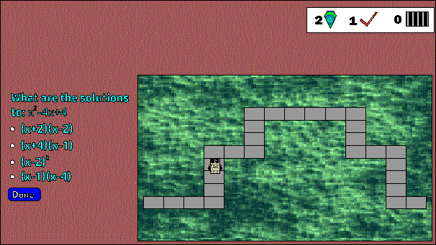

Position of the question and the “Done” button

USING THE “DONE” BUTTON

triesNumber ← 0 #total number of tries

SUB ClickedDone()

triesNumber++

IF triesNumber < 3

IF enteredAnswer = actualAnswer #if user is correct

OUTPUT(“Correct! Well done!”)

triesNumber ← 0 #reassigns 0 to the variable

LoadQuestion() #brings the next question

ELSE

OUTPUT(“Not quite right. Don’t worry, you still have ” + 3 – triesNumber + “ tries left.”)

ENDIF

ELSE

IF enteredAnswer = actualAnswer #if user is correct

OUTPUT(“Correct! Well done!”)

ELSE

OUTPUT(“Sorry, still not quite right.”)

ENDIF

triesNumber ← 0 #reassigns 0 to the variable

LoadQuestion() #brings the next question

ENDIF

ENDSUB

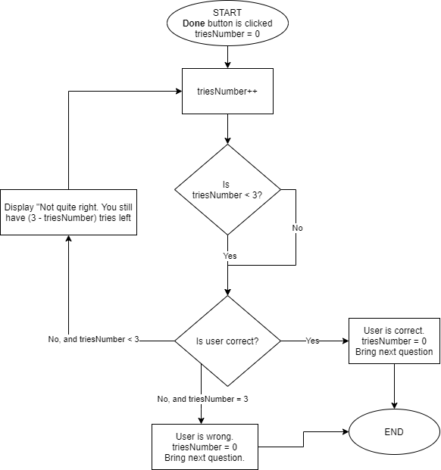

#### **Moving The Avatar Across The Track**

The basic objective of the game is to get the avatar to move from the start point to the end point of the track. With each correct answer, the avatar will move a random number of cells across the track.

Since I’m going to have different tracks for the avatar to move across, it is important to note that each track will most likely differ in the number of cells they have. This could definitely heavily how I intend to get the avatar to move a random number of cells across the track.

The following steps describe how I intend to accomplish this:

* As the game loads, the number of cells the chosen track has will be stored in **trackNumber**. So if for instance Track A has 30 cells in it, **trackNumber** ← 30.
* Since the user is answering only 10 questions per session, the avatar will be moving across the track 10 times. I will have a list of 10 numbers, called **cellMoveList**, and these numbers be randomly picked from the list and removed afterwards. These numbers will all sum up to **trackNumber**. Still using Track A as an example, if **trackNumber** = 30, then possible elements in **cellMoveList** could be [4, 2, 3, 5, 4, 2, 5, 3, 1, 1]. 4+2+3+5+4+2+5+3+1+1 = 30, so once the list has been emptied, ideally the game would be over.
* However, emptying the list wouldn’t necessarily guarantee the end of the game. The user may get a few questions wrong and thus not move across the track. So instead what ends the game is if **questionCount** = 10.
* In order to ensure that the avatar is moved accurately, I will have blocks of code that will determine how the avatar moves. Since any random number can be chosen as the number of cells the avatar can move, I will have blocks of code for when the avatar is at each point on the track and how many cells it should move. For instance, if I were to use the sample **cellMoveList** above, I will have blocks of code for if the avatar were to move 1-5 cells from each point on the track. This is to ensure that the avatar is moved accurately across the track no matter where it is on the track.
* The number randomly removed from the list will be stored in **randomCellNumber**. So for instance, if the random number 6 was generated, then **cellMoveList**[6] (starting counting index from 1) would be selected from the list, and so **randomCellNumber** ← 2, thus making the avatar move up by 2 cells. The number 2 will then be removed from the list, thus making **cellMoveList** ← [4, 2, 3, 5, 4, 5, 3, 1, 1].

#### **Adding The Total Number Of Coins Earned And Questions Answered**

The number of coins earned in a session will be the total of cells moved across the track, plus 2 multiplied by the number of questions answered correctly on first try.

The process goes like this:

* If a user answers a question correctly on the first try, 1 will be added to **firstTryAnswers**.
* If a user answers a question correctly (whether on first, second or third try), 1 will be added to **correctAnswers**.
* If a user answers incorrectly after three tries, 1 is added to **wrongAnswers**.
* The variable **totalCoinsEarned** will have its default value set to zero. If a user answers a question correctly and has moved across the track, **totalCoinsEarned** = **totalCoinsEarned** + **randomCellNumber**. This is adding the number of cells the avatar has moved along the track to the number of coins earned in that session.
* Once the game is over, **totalCoinsEarned** = **totalCoinsEarned** + (**2** * **correctAnswers**), adding the extra bonuses of 2 multiplied by the number of questions answered correctly on the first try.
* In the registry, the value of **TotalCoins** will be fetched, and **totalCoinsEarned** will be added to it. The new value will then overwrite the former value in the registry.

At the end of the game, the total coins earned by the user will be displayed, along with the questions they answered correctly and those they answered wrongly. The information will be displayed in a dialog window.

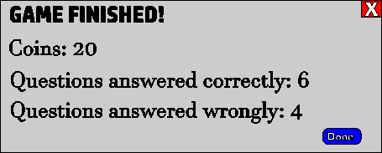

End results display

#### **Using Powerups**

There are three powerups in this game: Hint Gem, Question Skipper and Fast Track. These can be purchased from the store of the program.

Buttons for these powerups will be displayed at the bottom of the question, right below the “Done” button. These buttons will basically be the icons of each of these powerups, and the user can click on them to equip the powerup. When the mouse cursor hovers over each of the icons, it would display a tooltip giving a brief explanation of what the powerup does.

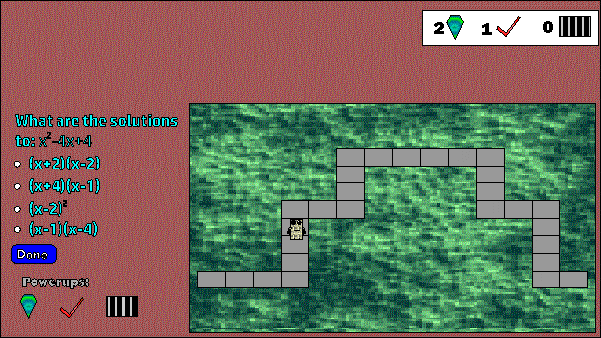

Powerup icons as seen in the game

1. **Hint Gems:** If the user is stuck on a question, the Hint Gems allows them to see a hint to help them solve the question. This can be used an indefinite number of times as long as they have more than 0 Hint Gems. The hint will be displayed in a dialog window, and as soon as the hint is displayed, 1 will be subtracted from **hintNumber** (of which the value has already been fetched from the registry) and the new value for **hintNumber** will overwrite the current value in the registry.

HINT GEMS

SUB UseHintGem() #after Hint Gems icon is clicked

IF hintNumber > 0

DisplayHint() #procedure to show hint

hintNumber ← hintNumber – 1

Registry.HintNumber ← hintNumber

#writes the new value to the registry

ELSE

OUTPUT(“Sorry, no hint gems available.”)

ENDIF

ENDSUB

1. **Question Skipper:** This allows the user to skip a question they’re finding difficult without losing any marks. It doesn’t necessarily mean that they’ll end the game faster, but this can allow them to skip a question and go to the next one without them risking failing the previous question. However, the Question Skipper can only be used twice in a single game session.

QUESTION SKIPPER

skipperUseCount ← 0

SUB UseQuestionSkipper()

skipperUseCount ← skipperUseCount + 1

IF skipperUseCount <= 2 AND skipNumber < 0

SkipQuestion()

#routine to skip the current question

skipNumber ← skipNumber – 1

Registry.SkipNumber ← skipNumber

#writes new value to registry

ELSE

IF skipperUseCount > 2

OUTPUT(“You have used all available Question Skippers for this session.”)

ENDIF

IF skipNumber = 0

OUTPUT(“You don’t have any Question Skippers available.”)

ENDIF

ENDIF

ENDSUB

1. **Fast Track:** This powerup allows the user to move faster across the track, enabling them to answer lesser questions and to finish a session faster. How is works is that once a user equips the Fast Track, they’ll be able to skip the question they’re on and the next question, and they will move across the track twice (as though they answered the questions correctly). Also, these two questions they’ve skipped will still be added to the total number of questions they’ve answered, thus enabling them to answer 2 less questions. However, this powerup can only be equipped once in a game session.

FAST TRACK

fastTrackUseCount ← 0

SUB UseFastTrack()

fastTrackUseCount ← fastTrackUseCount + 1

IF fastTrackUseCount = 1 AND trackNumber > 0

SkipQuestion()

SkipQuestion()

questionCount ← questionCount + 2

trackNumber ← trackNumber – 1

Registry.FastTrackNumber ← trackNumber

#writes new value to registry

ELSE

IF fastTrackUseCount > 1

OUTPUT(“You’ve used all available Fast Track for this session.”)

ENDIF

IF trackNumber = 0

OUTPUT(“You have no Fast Track available.”)

ENDIF

ENDIF

ENDSUB

#### **Pause and Restart System**

This bit will probably be the least significant part of the Play Game section. By the top right of the window, right above the box showing the powerups the user has, there will be three buttons, each by the side of the other. One will be the **Pause** button, another is **End Game** and the other **Restart**.

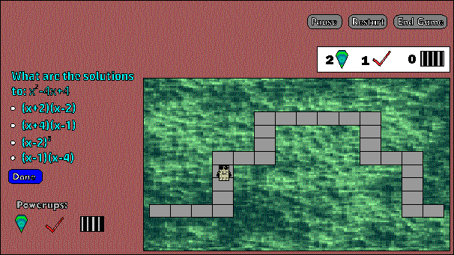

The Pause, Restart and End Game buttons

When the **Pause** button is clicked, a dialog box will appear and will say “Game paused. Click “OK” to continue”. At this point the user won’t be able to do anything in the game environment until they have clicked OK.

When the **End Game** button has been clicked, a dialog box will appear and ask “Are you sure you want to end the game? You will lose all your progress!”. If the user proceeds to click “Yes”, then everything is wiped, and all variables will be set to their default values. The user is then taken back to the main menu. But if the user clicks No, nothing happens and the game continues.

If the user clicks **Restart**, the same message box will still appear asking the user “Are you sure you want to restart? You’ll lose all your progress!”. If the user goes ahead and clicks Yes, then the same thing that happens with the End Game procedure happens, only difference is that instead of taking them back to the main menu, they start the game from the beginning, so they’ll go back to choose a subject, a topic and revision mode, thereby starting the game from the beginning. But if they choose No, then nothing happens and the game continues as normal.

## **Class Diagram**

Find the class diagram for the program on the next page:

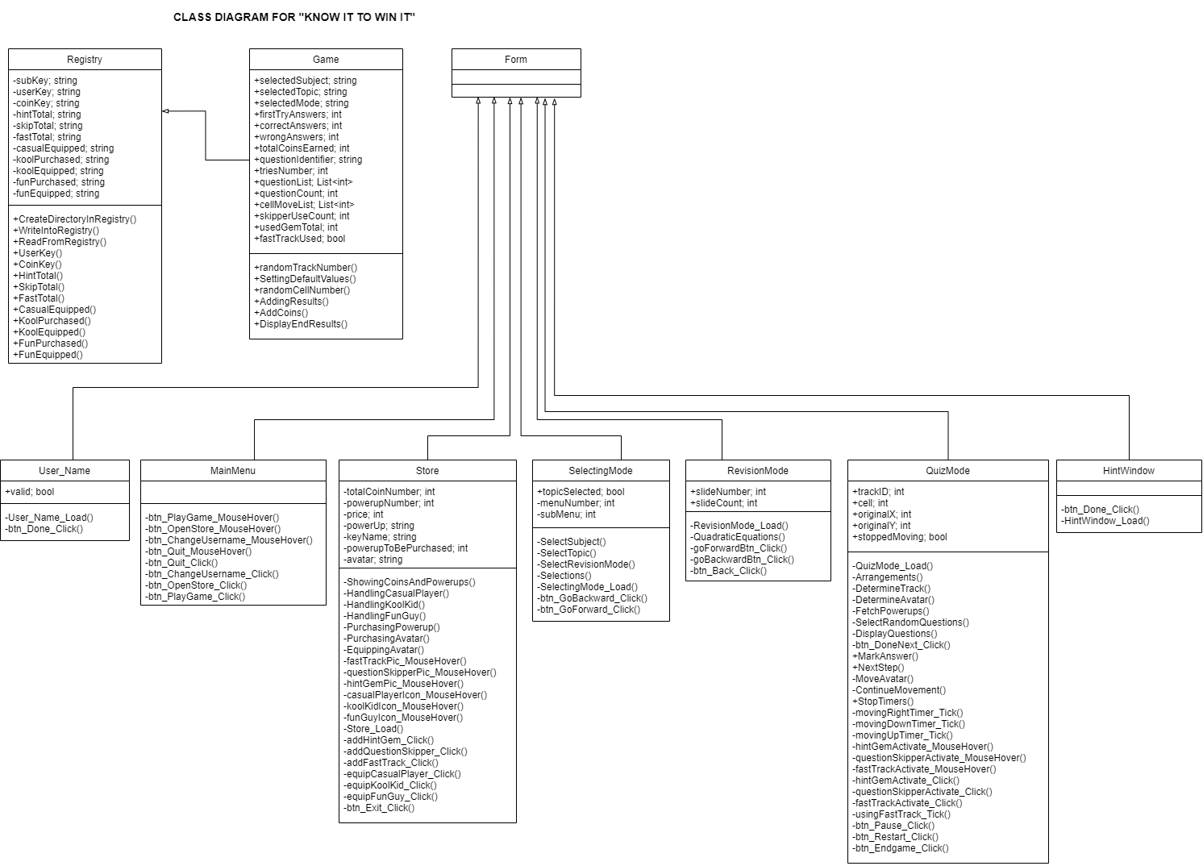

# **TECHNICAL SOLUTION**

While I was doing the design for my project, I made prototype applications of a few sections of the project to give me a better insight as to how these bits would work, and if they would work well. I used Console Applications to make these prototypes, so my design is partly based on them.

As I mentioned earlier, I’m going to be using C# Windows Forms to create the program, reasons being that it’s a whole lot easier to create a user interface using it, and it enables me to easily interact with my code and my objects. I will be using Microsoft Visual Studio as my IDE.

## **Creating the Project File**

The first step is to create the project. The template I’m using is the Windows Forms App, using the .NET framework. The .NET framework has more extensive libraries than .NET Core, so this would be more appropriate for my project.

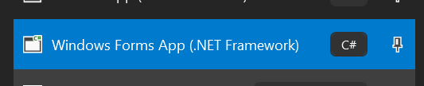

After selecting the template, the next thing to do is to give the project a name. I have given it the name **know_it_to_win_it_program**, as this will help for easier identification. Also the solution will be given the same name, so this will automatically give the namespace of the program the same name. In addition, I saved my project to a simple directory, so it is very easy for me to find my project to continue working on it whenever I need to.

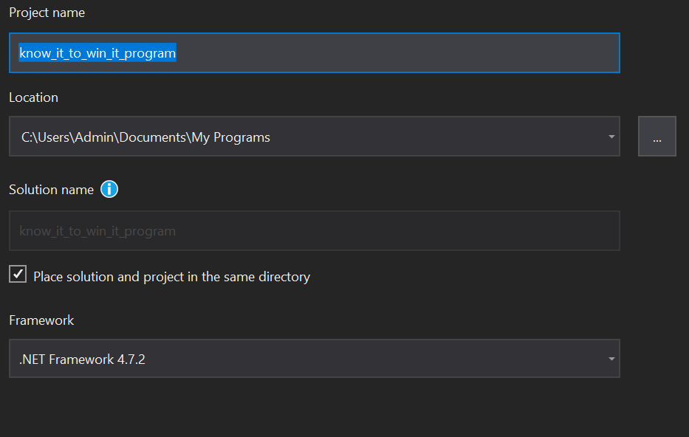

Since I’m working with interfaces, I need a place to keep all my designed graphics and backgrounds. I therefore created a folder which I am dedicating to storing all my graphics (in the form of pictures), which I will then import into the program when I need them.

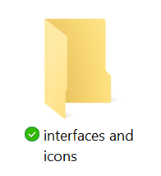

Now that I have created my project, the next step is to import my backgrounds, icons and related images. I will be saving these to the Resources properties category of my project, as this will enable me to easily locate these images so I can easily include them in my coding whenever I need them. Also, this would become stored into the folders containing the program files, so thus making it part of the program.

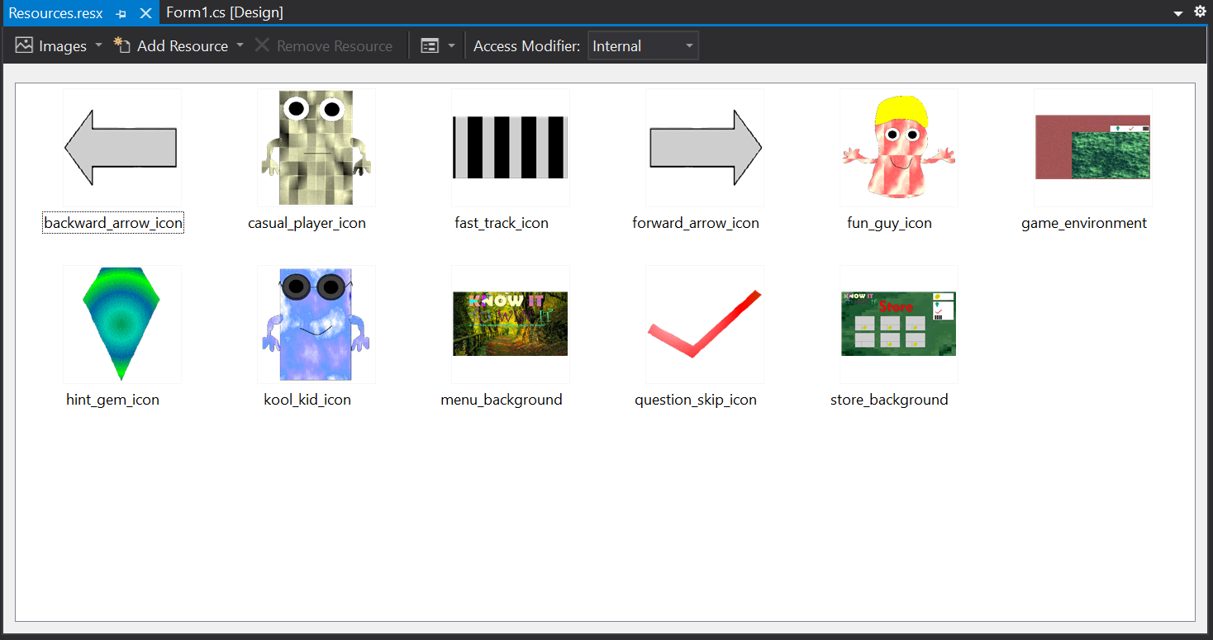

Images and graphics imported

## **Creating the Registry class**

As I’m going to be dealing with the registry, I need a place where I’m going to keep important key names which will be used to fetch and write values into the registry.

Below is my code for the **Registry** class, which will contain all main functions and routines concerning the registry.

class Registry

{

//registry keys

//I'm keeping the values constant because that makes them private, so they can't be changed by the program

const string subKey = @"SOFTWARE\Know It To Win It";//this is the subkey for the program with which it will store information in the registry

const string userKey = "USERNAME";//key name to store the username

public string UserKey()//this returns the key for the username as it has been made private by being made constant

{

return userKey;

}

const string coinKey = "TOTAL COINS";//key name to store the total number of coins earned throughout the game

public string CoinKey()

{

return coinKey;

}

const string hintTotal = "TOTAL HINT GEMS";//key name to store the total number of hint gems

public string HintTotal()

{

return hintTotal;

}

const string skipTotal = "TOTAL QUESTION SKIPPERS";//key name to store the total number of question skippers

public string SkipTotal()

{

return skipTotal;

}

const string fastTotal = "TOTAL FAST TRACK";//key name to store the total number of fast track powerups

public string FastTotal()

{

return fastTotal;

}

const string casualEquipped = "CASUAL PLAYER EQUIPPED";//key name to store the boolean value of if the casual player has been equipped

public string CasualEquipped()

{

return casualEquipped;

}

const string koolPurchased = "KOOL KID PURCHASED";//key name to store the boolean value of if the kool kid has been purchased

public string KoolPurchased()

{

return koolPurchased;

}

const string koolEquipped = "KOOL KID EQUIPPED";//key name to store the boolean value of if the kool kid has been equipped

public string KoolEquipped()

{

return koolEquipped;

}

const string funPurchased = "FUN GUY PURCHSED";//key name to store the boolean value of if the fun guy has been purchased

public string FunPurchased()

{

return funPurchased;

}

const string funEquipped = "FUN GUY EQUIPPED";//key name to store the boolean valkue of if the fun guy has been equipped

public string FunEquipped()

{

return funEquipped;

}

public void CreateDirectoryInRegistry()//creates the registry itself

{

RegistryKey sk = Microsoft.Win32.Registry.CurrentUser.CreateSubKey(subKey);//creates the registry object

sk.SetValue(userKey, "");//creates a default value for the username in the registry

sk.SetValue(coinKey, "0");//creates a default value for the coin total in the registry

sk.SetValue(hintTotal, "0");//creates a default value for the Hint Gem total in the registry

sk.SetValue(skipTotal, "0");//creates a default value for the Question Skipper total in the registry

sk.SetValue(fastTotal, "0");//creates a default value for the Fast Track total in the registry

sk.SetValue(casualEquipped, "true");//by default makes the equipped avatar Casual Player

sk.SetValue(koolPurchased, "false");//by default makes the Kool Kid not purchased

sk.SetValue(koolEquipped, "false");//by default makes the Kool Kid not equipped

sk.SetValue(funPurchased, "false");//by default makes the Fun Guy not purchased

sk.SetValue(funEquipped, "false");//by default makes the Fun Guy not equipped

}

public string ReadFromRegistry(string keyName)//this fetches a value from the registry

{

RegistryKey sk = Microsoft.Win32.Registry.CurrentUser.OpenSubKey(subKey);

if (sk == null)//if the subkey doesn't exist

{

return null;

}

else//if the subkey exists

{

return sk.GetValue(keyName).ToString();//fetches the value from that key name in the registry subkey

}

}

public void WriteIntoRegistry(string keyName, string value)//fetches a value from the registry

{

RegistryKey sk = Microsoft.Win32.Registry.CurrentUser.CreateSubKey(subKey);//opens a new key in the registry

sk.SetValue(keyName, value);//writes to the key

}

}

## **Coding the Start of the Program**

As planned out in my design, the user will be prompted to enter their username the first time the program is opened. Once this has been done, the user will then be taken to the main menu from there. And the next time the program is opened, it goes straight to the main menu.

As I’m using Windows Forms to create my project, I’ll have two different forms for the main menu window and the Enter Username window.

Below is my window for Enter Username:

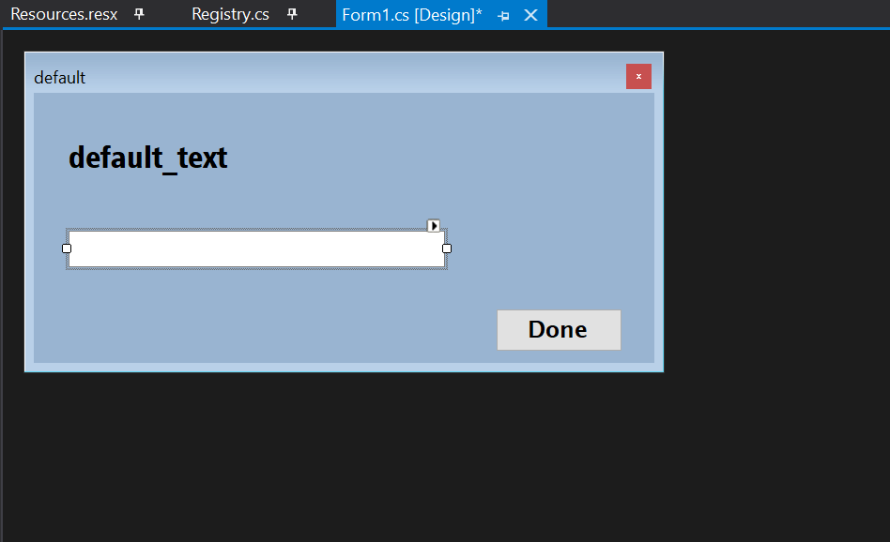

The text of the menu bar of the window has been set to **default**, because I’ll also be using this same window for the Change Username option that the user will select in the main menu, so the text will change depending on what it has been used for, and so will the label which has a text of **default_text**.

I have set the **FormBorderStyle** property (a property in Windows Forms that determines the category of a window) to **FixedDialog**, because this property disallows the window from changing its size, so the user can’t minimize, maximize or adjust the size of this window. In addition, I have also set the **StartPosition** property (a property in Windows Forms that lets you set the default position of the window when it has been loaded) to **CenterScreen**, which means that by default the window will appear in the middle of the desktop.

I have also put a text box beneath the label and a button at the right-hand bottom corner of the window. The user will enter their usernames into the text box and click the **Done** button after they’re done.

Now we move on to the coding.

First of all, I’ll design the code for what’s to happen when the window is loaded. To do so, I will create an event for when the window loads, and then add my code into it.

Below is my code for the event:

private void User_Name_Load(object sender, EventArgs e)//event called when the form is loaded

{

Registry r = new Registry();//creates an object for the registry

if (r.ReadFromRegistry(r.UserKey()) == "")//if the stored username in the registry is "", its default value

{

this.Text = "Create a Username";//the text read on the menu bar

default_text.Text = "Create a new username";//the label text

MessageBox.Show("Welcome to Know It To Win It! Please create your first username to get started!", "Welcome!", MessageBoxButtons.OK, MessageBoxIcon.Asterisk);

//message box to welcome the user into the game

}

else//registry exists hence there is already a pre-saved username

{

this.Text = "Change Username";//changes the text read on the menu bar

default_text.Text = "Enter your old username";//changes the text of the label

}

}

The next step is to create an event for when the **Done** button is clicked. There are three different this button will be clicked: when entering the username for the first time, when entering the previous username (to change it), and when entering the new username after entering the previous one to change it. As this event only takes place once when the button is clicked, it could cause some complications for if the user is changing their username, as the same window is used for the same purpose, and the **Done** button only works once. So to avoid this complication, I added a public static bool called valid so that if the user is changing their username, and they’ve entered the correct previous username, then the value of valid is set to true, so that they can proceed with changing their username. Afterwards the value is set back to false and the window closed.

Below is the code for this event:

private void btn_Done_Click(object sender, EventArgs e)

{

Registry registryValues = new Registry();//creates the registryValues object

if (nameEntry.Text == "" || nameEntry.Text.Contains(" ") || nameEntry.Text.Length < 5)//in case the user mischieviously (or accidentaly) doesn't enter anything into the textbox or their username doesn't fit with the standards

{

MessageBox.Show("The value you have entered is invalid. Please enter a username with 5 or more characters and no spaces.", "Invalid entry", MessageBoxButtons.OK, MessageBoxIcon.Error);

}

else if (registryValues.ReadFromRegistry(registryValues.UserKey()) != null && valid == true)//if there has been an entry into the textbox which meets the requirements and there is a value stored in the registry for the username and the user has already previously entered their former username

{

registryValues.WriteIntoRegistry(registryValues.UserKey(), nameEntry.Text);//saves the new value into the registry

MessageBox.Show("You have succesfully changed your username!", "Username changed", MessageBoxButtons.OK, MessageBoxIcon.Information);

System.Threading.Thread.Sleep(750);

valid = false;//resets the value back to false

this.Close();//closes this window

}

else//if the user has entered something and it doesn't meet the conditions above

{

if (registryValues.ReadFromRegistry(registryValues.UserKey()) == "")//if there hasn't been a new saved value for the username in the registry; it's still the default value of ""

{

registryValues.WriteIntoRegistry(registryValues.UserKey(), nameEntry.Text);//writes the value into the registry

MessageBox.Show("You have succesfully entered a username!", "Well done", MessageBoxButtons.OK, MessageBoxIcon.Information);

System.Threading.Thread.Sleep(750);

this.Close();//eventually closes the program after the menu form has been closed

}

else//if there is already a saved value in the registry for the username

{

if (nameEntry.Text == registryValues.ReadFromRegistry(registryValues.UserKey()))//if the user has correctly entered their current username

{

valid = true;//changes the boolean value to true

default_text.Text = "Enter your new username";

}

else//if the username entered is not correct

{

valid = false;//keeps the boolean value false

MessageBox.Show("You have entered the wrong username. Please try again.", "Wrong entry", MessageBoxButtons.OK, MessageBoxIcon.Error);

}

}

}

nameEntry.Text = "";//empties the textbox of any values entered

}

(nameEntry is the identifier for the textbox, and any value entered by the user is stored in nameEntry.Text).

The next step is then creating the window for the main menu of the program. To do this, I will create a new form within my project in Windows Forms, and I will be calling the new form **MainMenu**.

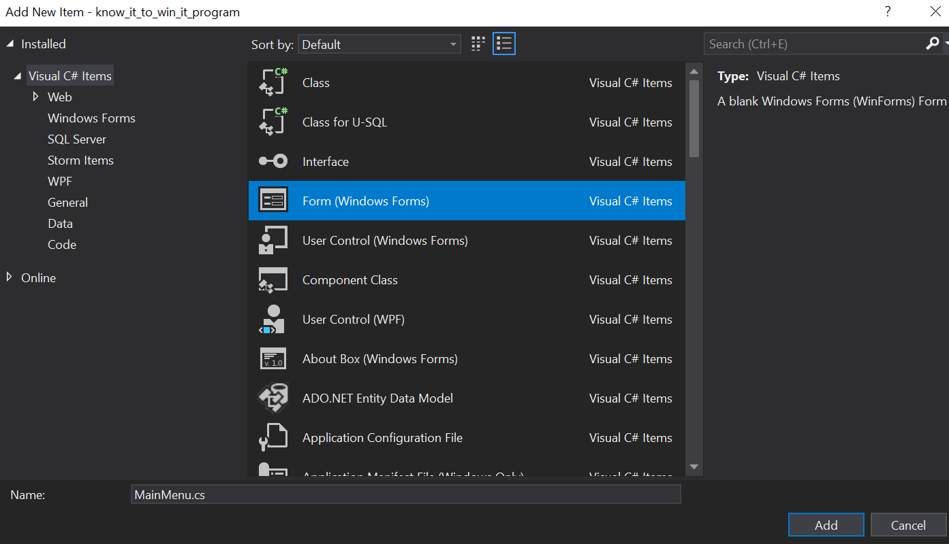

On creating the new window, I will then go back to my code for the Username window and add the lines of code to open the window for the main menu after the username has been created for the first time.

Before I make any extra additions though, the next thing I will do is to go to the class **Program.cs** file. The code in this file is run when the program is loaded, and it determines which form will be opened first, and this form will be sort of like the container by which the program will be loaded into the RAM. I will then make some adjustments to the code in **Program.cs** so that the Enter Username form is loaded first when the program is loaded for the first time, that is, if the registry hasn’t been created yet.

Below is the original code in **Program.cs**:

using System;

using System.Collections.Generic;

using System.Linq;

using System.Threading.Tasks;

using System.Windows.Forms;

namespace know_it_to_win_it_program

{

static class Program

{

/// <summary>

/// The main entry point for the application.

/// </summary>

[STAThread]

static void Main()

{

Application.EnableVisualStyles();

Application.SetCompatibleTextRenderingDefault(false);

Application.Run(new User_Name());

}

}

}

I will only be making edits to the Main() void, as this is the procedure run when the program is started. The Application.Run() procedure calls the form that will be opened and loaded into the RAM, so I will need to make some changes to this line so that it will open the Username form on the first time the app is loaded, and then it loads the main menu form the next times the app is run.

Below is the modified code for the Main() void:

static void Main()

{

Registry r = new Registry();

Application.EnableVisualStyles();

Application.SetCompatibleTextRenderingDefault(false);

if (r.ReadFromRegistry(r.UserKey()) == null)//if the registry doesn't exist

{

r.CreateDirectoryInRegistry();//this creates the registry directory once the program is opened the first time

Application.Run(new User_Name());//opens the Username form

}

Application.Run(new MainMenu());//opens the main menu form

}

Once the if statement is reached, the line r.CreateDirectoryInRegistry() is run. This line links to the CreateDirectoryInRegistry() void in the Registry class which creates that subkey in the registry and assigns default values for the various variables to be stored in the registry, which will be fetched later. This is done the first time the program is opened, and will be done only this once.

## **The Main Menu**

After creating the form for the Main Menu, I will bring in the background. I have already saved this background in the Resources.resx directory, so I can easily fetch the picture. So the form’s BackgroundImage property now becomes the image menu_background.jpg. In addition, I will also change the BackgroundImageLayout property (which determines how the image is fitted in the form) from its default value of Tile to Stretch.

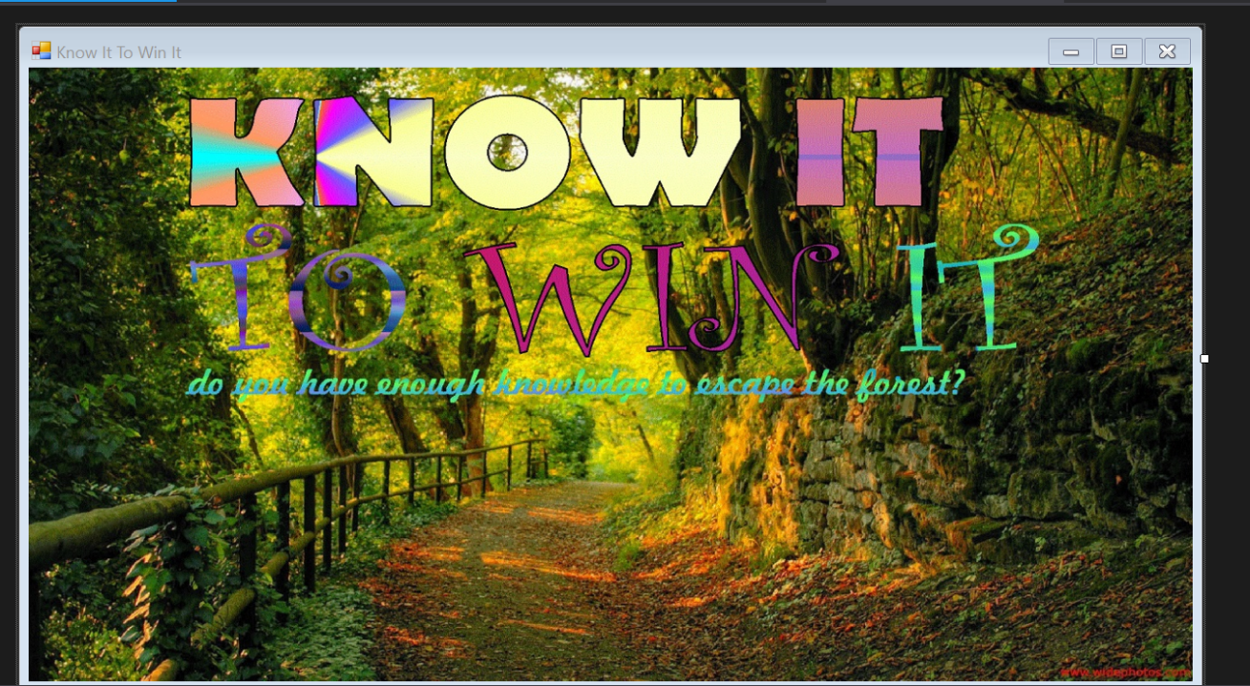

Creating the main menu interface

The next step will be to add the various buttons (Play Game, Store, Change Username, Quit). To do this, I will go to the toolbox and insert 4 button objects onto the form. I will also change some properties of the buttons to make them look less basic and more authentic. I will also align the buttons appropriately so they have equal spacing between each of them and will put them at an appropriate place on the form. I will also given the button objects appropriate names, so the Play Game button has been the given the name btn_PlayGame, the Store button named btn_OpenStore, the Change Username button named btn_ChangeUsername and the Quit button has been named btn_Quit.

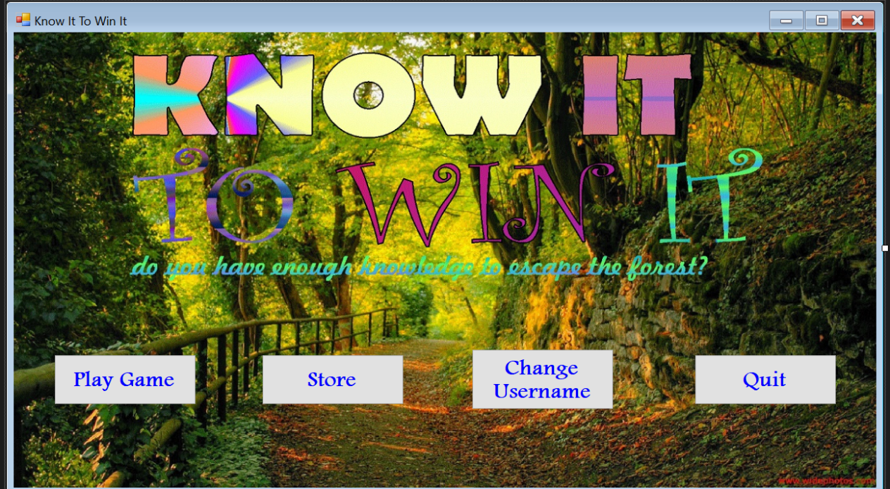

Adding buttons to the interface

As I mentioned in my design segment, I said that I would add a tooltip to the buttons which will briefly display what each button would do. So in order to do so, I will add a tooltip object to my form as well. I will then create events for when the mouse cursor hovers over the buttons and then code the text to be displayed by the tooltip. I will create separate events for each of the buttons.

Below is the code for this:

private void btn_PlayGame_MouseHover(object sender, EventArgs e)//event for when the mouse hovers over the Play Game button

{

toolTip1.SetToolTip(btn_PlayGame, "Ready to play and test your knowledge? Click here to begin!");//the text to be displayed

}

private void btn_OpenStore_MouseHover(object sender, EventArgs e)//event for when the mouse hovers over the Store button

{

toolTip1.SetToolTip(btn_OpenStore, "Need a powerup or a new avatar? Come to the Store and make\nyour purchases to make your game experiece spectacular!");

}

private void btn_ChangeUsername_MouseHover(object sender, EventArgs e)//event for when the mouse hovers over the Change Username button

{

toolTip1.SetToolTip(btn_ChangeUsername, "Not feeling your old username? Come on here and change\nit to something more exciting!"); ;

}

private void btn_Quit_MouseHover(object sender, EventArgs e)//event for when the mouse hovers over the Quit button

{

toolTip1.SetToolTip(btn_Quit, "Click here to quit. Hope to see you soon!");

}

The next thing to do is to create events for what happens when the buttons are clicked.

First, I created the event for what will happen when the Quit button is clicked, as it is pretty straightforward and doesn’t take any time. Basically once the button has been clicked, it will display a farewell message and then close the form, and thereby closing the program.

Next is to create the event for what happens when the Change Username button is clicked. The Enter Username form that I have already created will also be used to change the username, so clicking the Change Username button will still load the form. The only difference now is that the text displayed will change from “Enter a new username” to “Enter your old username”, and the text on the menu bar will now be “Change Your Username”. It will also open the Enter Username form as a dialog box and not as an actual window.

After this, next will be to create events for when the Store and Play Game buttons are clicked. And from there on, the next thing to do is to create a new form for the Store.

## **The Store**

The next thing to do is to create the store. To do this, I will create another form, which will serve as the window for the store. Then I will link the Main Menu to the store by writing the code in the main menu form that will open the store.

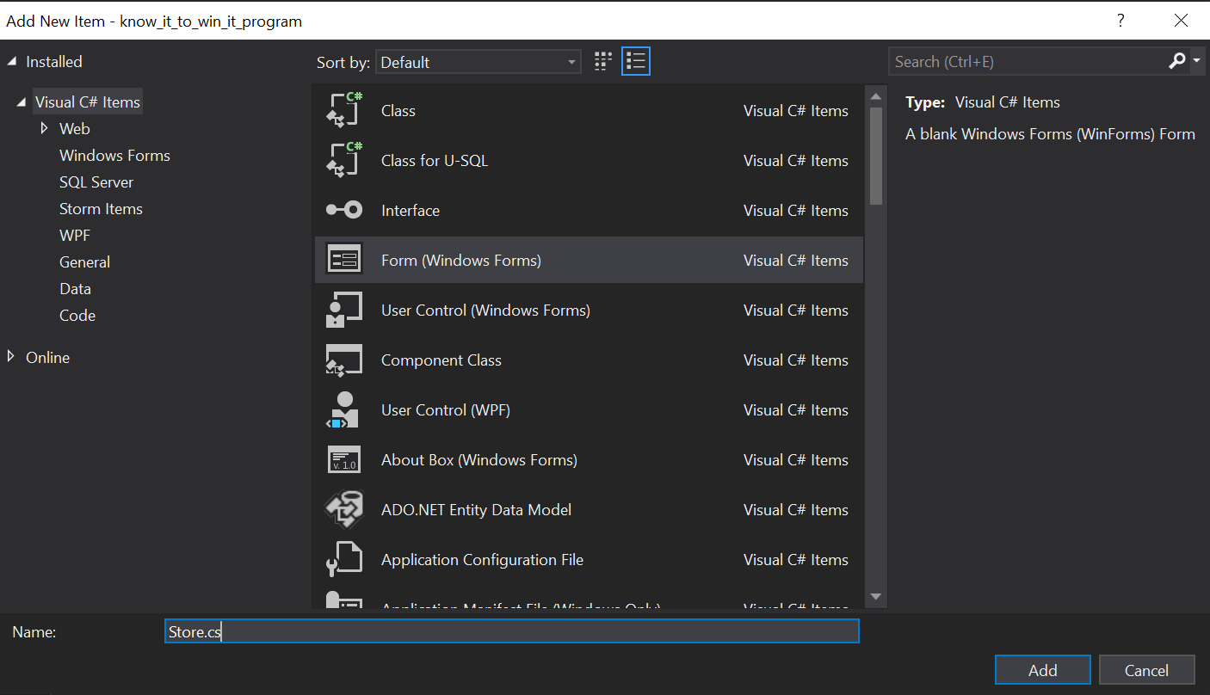

Creating the Store window

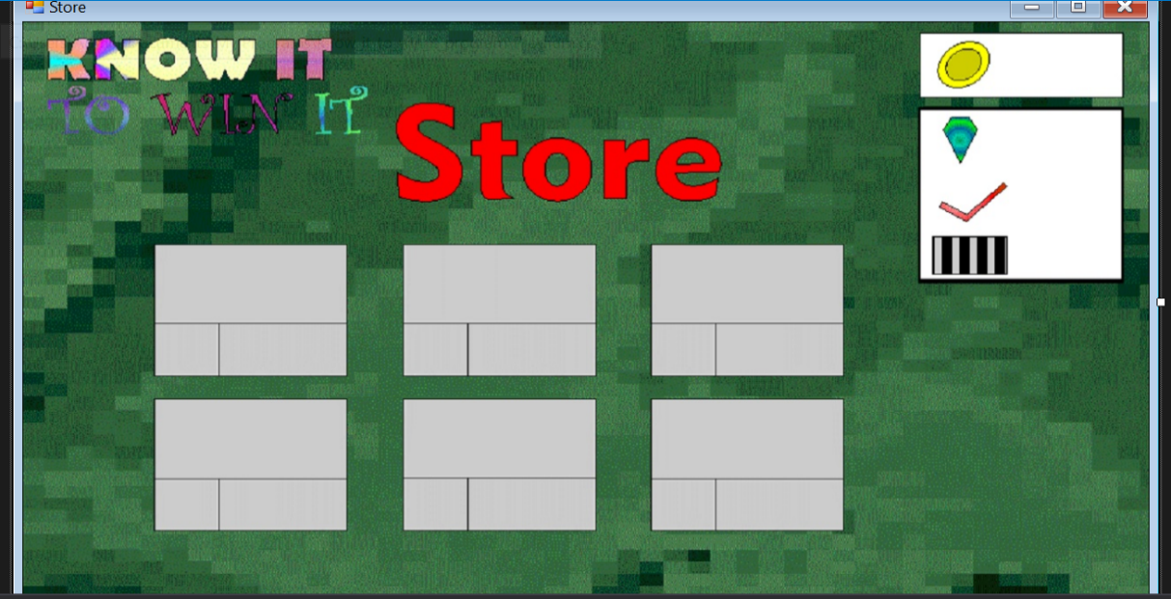

Creating the Store window

The next step will be to add the various elements: coin number, avatars, powerups etc.

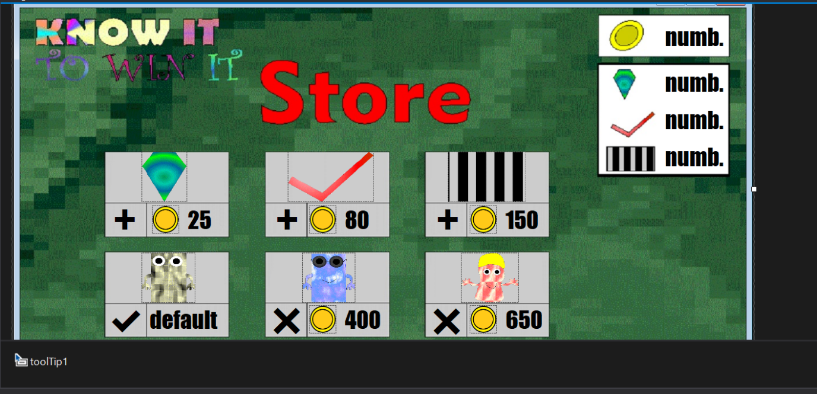

The Store window with the added elements

I have given each of these elements identifier names. These names will make it easier for me to code the various activities in the store. I have also added a tooltip to the form so that I can put some more information about each of these powerups and avatars. I changed the cursor for the powerups and avatars to the **Help** cursor, so when the user brings their cursor over these objects, it turns into the **Help** cursor and then the text in the tooltip appears, giving them some more information about the powerup.

Below is the code for the tooltips:

private void fastTrackPic_MouseHover(object sender, EventArgs e)//for when the mouse hovers over the Fast Track

{

toolTip1.SetToolTip(fastTrackPic, "The Fast Track powerup will enable you to move\nfaster in the game whilst answering lesser questions.");

}

private void questionSkipperPic_MouseHover(object sender, EventArgs e)//for when the mouse hovers over the question skipper

{

toolTip1.SetToolTip(questionSkipperPic, "Finding a question difficult? The Question Skipper\nwill enable you to skip the question and move on\nto the next one without affecting your number of\ncorrectly answered questions! How cool is that?");

}

private void hintGemPic_MouseHover(object sender, EventArgs e)//for when the mouse hovers over the hint gem

{

toolTip1.SetToolTip(hintGemPic, "Are you stuck in a question and don't know where to\ngo from there? Use the Hint Gem to get yourself a\nhint to handle that question! ;)");

}

private void casualPlayerIcon_MouseHover(object sender, EventArgs e)//for when the mouse hovers over the casual player

{

toolTip1.SetToolTip(casualPlayerIcon, "The Casual Player");

}

private void koolKidIcon_MouseHover(object sender, EventArgs e)//for when the mouse hovers over the kool kid

{

toolTip1.SetToolTip(koolKidIcon, "The Kool Kid");

}

private void funGuyIcon_MouseHover(object sender, EventArgs e)//for when the mouse hovers over the fun guy

{

toolTip1.SetToolTip(funGuyIcon, "The Fun Guy");

}

After that I will continue coding into the Store class with the other procedures needed for the store, such as loading the store and making a purchase.

Below is the code for when the form is loaded:

private void Store_Load(object sender, EventArgs e)//when the store is loaded

{

ShowingCoinsAndPowerups();//void to display the coins

}

void ShowingCoinsAndPowerups()//the procedure for displaying the number of coins and powerups

{

Registry r = new Registry();//creating object for the registry class

coinNumber.Text = r.ReadFromRegistry(r.CoinKey());//fetching value of total coins from registry and displaying it on the screen

hintGemNumber.Text = r.ReadFromRegistry(r.HintTotal());//fetching value of total hint gems from registry and displaying it on the screen

questionSkipNumber.Text = r.ReadFromRegistry(r.SkipTotal());//fetching value of question skippers from registry and displaying it on the screen

fastTrackNum.Text = r.ReadFromRegistry(r.SkipTotal());//fetching the value of total fast track powerups from the registry and displaying it on the screen

HandlingCasualPlayer(r);//calls this to handle the displaying of the Casual Player Avatar

HandlingKoolKid(r);//calls this to handle the displaying of the Kool Kid avatar

HandlingFunGuy(r);//calls this to handle the displaying of the Fun Guy avatar

}

void HandlingCasualPlayer(Registry r)//this handles how the Casual Player is being displayed in the store

{

if (bool.Parse(r.ReadFromRegistry(r.CasualEquipped())) == true)//if the Casual Player is equipped

{

equipCasualPlayer.Text = "✔";//shows the tick to indicate it's been equipped

casualPlayerText.Text = "Equipped";//shows the text to indicate it's been equipped as well

}

else//if the casual player is not equipped

{

equipCasualPlayer.Text = "✖";//shows the x to indicate it's not equipped

casualPlayerText.Text = "NIL";//shows NIL to indicate it's not equipped as well

}

}

void HandlingKoolKid(Registry r)//this handles how the Kool Kid is being displayed in the store

{

if (bool.Parse(r.ReadFromRegistry(r.KoolEquipped())) == true && bool.Parse(r.ReadFromRegistry(r.KoolPurchased())) == true)//if the kool kid has been purchased and has been equipped

{

equipKoolKid.Text = "✔";//shows the kool kid has been equipped

koolKidCoin.Visible = false;//makes the coin icon invisible signifying that the user has purchased it

koolKidText.Location = koolKidCoin.Location;//gives the text for the kool kid the same location as the picture

koolKidText.Text = "Equipped";//shows the text to indicate it has been equipped

}

else if (bool.Parse(r.ReadFromRegistry(r.KoolPurchased())) == false)//if it hasn't been purchased

{

equipKoolKid.Text = "+";//shows the + sign so the user can purchase the avatar

//KoolPurchased() is only false until it has been purchased, and so KoolEquipped() remains false till it has been

//purchased and equipped. Once KoolPurchased() is true, it can never go back to false

}

else if (bool.Parse(r.ReadFromRegistry(r.KoolEquipped())) == false)//if purchased but not equipped

{

equipKoolKid.Text = "✖";//shows the kool kid has been purchased but not equipped

koolKidCoin.Visible = false;//makes the coin icon invisible signifying that the user has purchased it

koolKidText.Location = koolKidCoin.Location;//gives the text for the kool kid the same location as the picture

koolKidText.Text = "NIL";//shows the text to indicate it has been purchased but not equipped

}

}

void HandlingFunGuy(Registry r)//this handles how the Fun Guy is being displayed in the store

{

if (bool.Parse(r.ReadFromRegistry(r.FunEquipped())) == true && bool.Parse(r.ReadFromRegistry(r.FunPurchased())) == true)//if the Fun Guy has been purchased and has been equipped

{

equipFunGuy.Text = "✔";//shows the Fun Guy has been equipped

funGuyCoin.Visible = false;//makes the coin icon invisible signifying that the user has purchased it

funGuyText.Location = funGuyCoin.Location;//gives the text for the Fun Guy the same location as the picture

funGuyText.Text = "Equipped";//shows the text to indicate it has been equipped

}

else if (bool.Parse(r.ReadFromRegistry(r.FunPurchased())) == false)//if it hasn't been purchased

{

equipFunGuy.Text = "+";//shows the + sign so the user can purchase the avatar

//FunPurchased() is only false until it has been purchased, and so FunEquipped() remains false till it has been

//purchased and equipped. Once FunPurchased() is true, it can never go back to false

}

else if (bool.Parse(r.ReadFromRegistry(r.FunEquipped())) == false)//if purchased but not equipped

{

equipFunGuy.Text = "✖";//shows the kool kid has been purchased but not equipped

funGuyCoin.Visible = false;//makes the coin icon invisible signifying that the user has purchased it

funGuyText.Location = funGuyCoin.Location;//gives the text for the Fun Guy the same location as the picture

funGuyText.Text = "NIL";//shows the text to indicate it has been purchased but not equipped

}

}

After that the next thing to do is to code the purchase of the powerups. There are three buttons that will perform the exact same function, difference being that the powerups purchased are different, but the process of purchase will be exactly the same. To make coding efficient, I will make a separate void that will handle the purchase of powerups in general, and then the events called on clicking each of the buttons will all call this void which will handle the purchase of the powerups.

Below is my code for this:

int totalCoinNumber;//total number of coins

int powerupNumber;//the total number of that powerup

int price;//the price of the powerup or avatar to be purchased

string powerUp;//the powerup to be purchased

string keyName;//the keyname that will be used to write something into the registry

int powerupToBePurchased;//this is an integer identifier for the powerup to be purchased, which is identified from 1 to 3

private void addHintGem_Click(object sender, EventArgs e)//event for purchasing a Hint Gem

{

powerupToBePurchased = 1;//assigns the number 1

PurchasingPowerup();//calls the procedure to purchase the powerup

}

private void addQuestionSkipper_Click(object sender, EventArgs e)//event for purchasing a Question Skipper

{

powerupToBePurchased = 2;//assigns the number 2

PurchasingPowerup();//calls the procedure to purchase the powerup

}

private void addFastTrack_Click(object sender, EventArgs e)//event for purchasing a Fast Track

{

powerupToBePurchased = 3;//assigns the number 3

PurchasingPowerup();//calls the procedure to purchase the powerup

}

void PurchasingPowerup()//this handles the purchasing of a powerup

{

totalCoinNumber = int.Parse(coinNumber.Text);//gets the value of the coin number which has already been fetched from the registry

Registry r = new Registry();//object for the registry

switch (powerupToBePurchased)

{

case 1://if the hint gem was to be purchased

price = int.Parse(hintGemPrice.Text);//taking the value already presented in the store and converting it to an int

powerUp = "Hint Gem";

powerupNumber = int.Parse(hintGemNumber.Text);//gets the value of the total number of hint gems

keyName = r.HintTotal();//the keyname to store total hint gems

break;

case 2://if the question skipper was to be purchased

price = int.Parse(questionSkipperPrice.Text);//taking the value already presented in the store and converting it to an int

powerUp = "Question Skipper";

powerupNumber = int.Parse(questionSkipNumber.Text); //gets the value of the total number of question skippers

keyName = r.SkipTotal();//the keyname to store total question skippers

break;

case 3://if the fast track was to be purchased

price = int.Parse(fastTrackPrice.Text);//taking the value already presented in the store and converting it to an int

powerUp = "Fast Track";

powerupNumber = int.Parse(fastTrackNum.Text);//gets the value of the total number of fast track powerups

keyName = r.FastTotal();//the keyname to store total fast track

break;

}

if (totalCoinNumber >= price)//the user has enough coins to purchase the powerup

{

r.WriteIntoRegistry(keyName, (powerupNumber++).ToString());//writes the new number of that powerup into the registry

r.WriteIntoRegistry(r.CoinKey(), (totalCoinNumber - price).ToString());//writes the new number of total coins to the registry

MessageBox.Show("You have succesfully purchased a " + powerUp + "!", "Purchase succesful", MessageBoxButtons.OK, MessageBoxIcon.Information);//displays the message that the user has purchased a new powerup

ShowingCoinsAndPowerups();//this reruns the void to display the new amounts of coins and powerups

}

else//user doesn't have enough coins

{

Thread.Sleep(500);//delays the time by 500ms

MessageBox.Show("Sorry, you do not have enough coins to purchase The " + powerUp + " as you do not have enough coins. Earn some more coins and then try again.", "Not enough coins!", MessageBoxButtons.OK, MessageBoxIcon.Error);

//displays a message to show that the user doesn't have enough coins

}

}

The next step will be to code the purchasing and equipping of a powerup. There will be different procedures to handle these events, and they will have to be carefully coded, because only one avatar can be equipped at a time, and once an avatar has been purchased it remains there permanently. How this would work is rather simple. The Casual Player is selected by default when the program is loaded, unless the user had equipped a different avatar. If they haven’t purchased another avatar, then the prices of such avatars will still be displayed, and there will be a **+** next to them. Once they have purchased the avatars, the prices will no longer be displayed and the texts will instead now display **NIL** along with an **X**. Once the user clicks on the **X**, the avatar is equipped and the previously equipped avatar is unequipped.

Below is my code for this:

int avatarToBePurchased;//this is an integer identifier for the avatar to be purchased, which is identified from 1 to 2

int avatarToBeEquipped;//this is an integer identifier for the avatar to be equipped, which is identified from 1 to 3

string avatar;//the avatar to be purchased or equipped

private void equipCasualPlayer_Click(object sender, EventArgs e)//event when the button for the casual player is clicked

{

avatarToBeEquipped = 1;

EquippingAvatar();//goes straight to equip the avatar since it doesn't need to be purchased

}

private void equipKoolKid_Click(object sender, EventArgs e)//event when the button for the Kool Kid is clicked

{

Registry r = new Registry();//creating the registry for the object

if (bool.Parse(r.ReadFromRegistry(r.KoolPurchased())) == false)//if the Kool Kid has not been purchased

{

avatarToBePurchased = 1;

PurchasingAvatar();//goes to purchase the avatar

}

else//if the avatar has been purchased

{

avatarToBeEquipped = 2;

EquippingAvatar();//goes to equip the avatar

}

}

private void equipFunGuy_Click(object sender, EventArgs e)//event when the Fun Guy is clicked

{

Registry r = new Registry();//creating the registry for the object

if (bool.Parse(r.ReadFromRegistry(r.FunPurchased())) == false)//if the Fun Guy has not been purchased

{

avatarToBePurchased = 2;

PurchasingAvatar();//goes to purchase the avatar

}

else//if the avatar has been purchased

{

avatarToBeEquipped = 3;

EquippingAvatar();//goes to equip the avatar

}

}

void PurchasingAvatar()//this handles the purchasing of an avatar

{

totalCoinNumber = int.Parse(coinNumber.Text);//gets the value of the coin number which has already been loaded from the registry

Registry r = new Registry();//creates an object for the registry

switch (avatarToBePurchased)

{

case 1://if Kool Kid were to be purchased

price = int.Parse(koolKidText.Text);//gets the price from the store

avatar = "Kool Kid";//the name of the powerup

keyName = r.KoolPurchased();//the keyname to store it in the registry

break;

case 2://if Fun Guy were to be purchased

price = int.Parse(funGuyText.Text);//gets the price from the store

avatar = "Fun Guy";//the name of the powerup

keyName = r.FunPurchased();//the keyname to store it in the registr

break;

}

if (totalCoinNumber >= price)//if the user has enough coins

{

r.WriteIntoRegistry(keyName, "true");//notifies that the powerup is now purchased

r.WriteIntoRegistry(r.CoinKey(), (totalCoinNumber - price).ToString());//writes the new number of total coins to the registry

MessageBox.Show("You have succesfully purchased the " + avatar + " avatar!", "Purchase succesful", MessageBoxButtons.OK, MessageBoxIcon.Information);//displays the message that the user has purchased a new powerup

ShowingCoinsAndPowerups();//this reruns the void to display the purchase and equipping of these avatars

}

else

{

Thread.Sleep(500);//delays the time by 500ms

MessageBox.Show("Sorry, you do not have enough coins to purchase The " + powerUp + " as you do not have enough coins. Earn some more coins and then try again.", "Not enough coins!", MessageBoxButtons.OK, MessageBoxIcon.Error);

//displays a message to show that the user doesn't have enough coins

}

}

void EquippingAvatar()//this handles the equipping of an avatar

{

Registry r = new Registry();//object for the registry

switch (avatarToBeEquipped)

{

case 1://if casual player were to be equipped

keyName = r.CasualEquipped();//the keyname for the casual player

avatar = "Casual Player";

r.WriteIntoRegistry(r.KoolEquipped(), "false");//makes the Kool Kid unequipped

r.WriteIntoRegistry(r.FunEquipped(), "false");//makes the Fun Guy unequipped

break;

case 2://if kool kid were to be equipped

keyName = r.KoolEquipped();//the keyname for the Kool Kid

avatar = "Kool Kid";

r.WriteIntoRegistry(r.CasualEquipped(), "false");//makes the Casual Player unequipped

r.WriteIntoRegistry(r.FunEquipped(), "false");//makes the Fun Guy unequipped

break;

case 3://if fun guy were to be equipped

keyName = r.FunEquipped();//the keyname for the casual player

avatar = "Fun Guy";

r.WriteIntoRegistry(r.KoolEquipped(), "false");//makes the Kool Kid unequipped

r.WriteIntoRegistry(r.CasualEquipped(), "false");//makes the Casual Player unequipped

break;

}

r.WriteIntoRegistry(keyName, "true");//makes the selected avatar equipped

MessageBox.Show("You have succesfully equipped the " + avatar + " Avatar!", "Avatar equipped", MessageBoxButtons.OK, MessageBoxIcon.Information);

//the dialog box to show that the avatar has been equipped

ShowingCoinsAndPowerups();//this reruns this void to show the purchase and equipping of avatars and powerups

}

After this the next and final thing to do in the store is to write the code for the **Home** button. Basically, I will create an event for when the button is clicked, and that event will basically close the Store form, and show the Main Menu form.

## **Play Game**

The Play Game procedure is the main bit of the program now. It contains two bits: the Revision Mode and the Quiz Mode. The user has the option to choose either of these modes by the time they’ve selected the Play Game button by navigating through submenus of their preferences which include subject, topic and mode of learning.

The Revision mode mainly just features flashcards with short, brief and straight-to-the-point revision flashcards which have been prepared by me. Initially I wanted to include some brief revision questions into the revision mode, but as time is running out, I will prefer to keep it restricted to just the flashcards. The revision questions will come in later in the quiz mode, where the main game happens.

In the quiz mode, based on the subject and topic selected by the user, a series of random questions will be asked which the user is meant to answer. There is a track divided into a number of cells to the right of the screen on which the avatar will move across when the user gets a question correct. Here the user will be able to earn coins with which they can spend in the store to get more powerups and/or purchase other avatars to make their gaming experience more fun and enjoyable.

This is going to be the largest part of my program, and it’s possible I may not finish all the topics I initially intended to. However I aim to at least complete one topic and to get the mechanism up and running, even if I’m not able to finish every single thing when the time is up.

### **Choosing the Revision Environment**

From what I had designed, when the **Play Game** button is clicked, it will display a submenu asking the user to select their preferred subject, and then their preferred topic and then their preferred learning mode. These will appear in the same form and the elements in the form will change based on which stage they’re in in selecting their learning environment.

So first I will create the form:

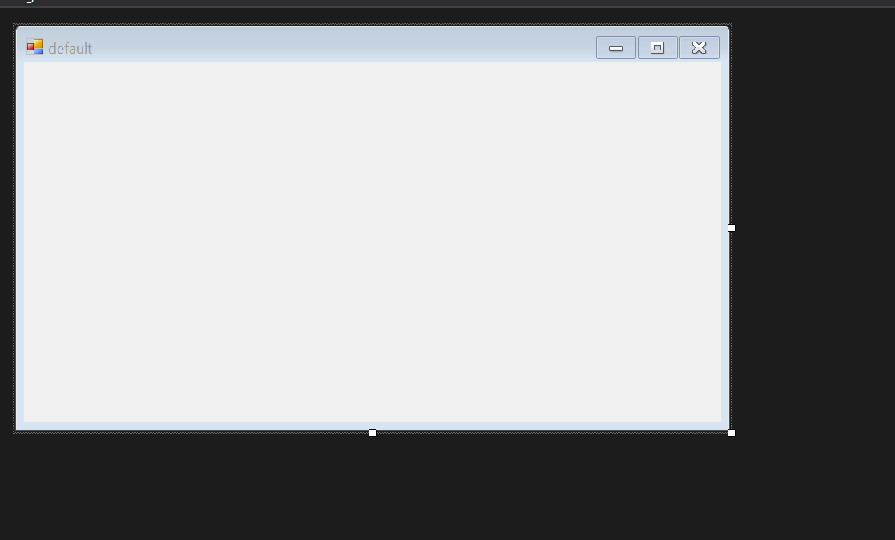

Created form for choosing the learning environment the user wants

Next, I will change some form properties to make it more appropriate for the function. First of all I will change StartPosition property from WindowsDefaultLocation to CentreParent, making it appear in the middle of the main menu as a dialog box, as it will be called in that manner. Then I’ll change the FormBorderStyle to FixedToolWindow so that it looks more like a dialog box and can’t be resized by the user.

The next thing will be to add elements. I will add a label, a few radio buttons (which allow the user to select only one option) and then **Next** and **Back** buttons.

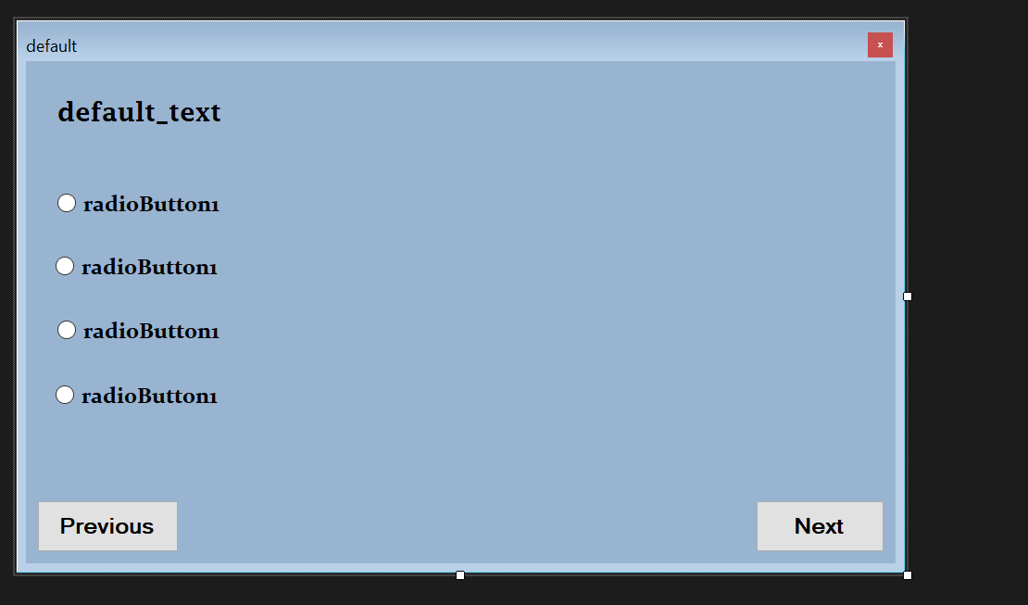

Inserting elements into the form

The next step will then be to write the coding for this form. Because I’m using this form to display three different submenus, the elements in the form will change depending on different factors defining each of the submenus. So some of the radio buttons will be featured and others won’t be featured depending on the submenu. And the texts will also differ depending on which submenu it is.

Below is my code for this:

public static bool topicSelected = false;//returns a boolean value to tell the Play Game function in the main menu what to do in the

//event that a topic wasn't selected and the dialog box was just closed

int menuNumber = 1;//a counter for the different submenus that appear, automatically starts from 1

int subMenu;//identifier fot the different submenus

void SelectSubject()//first submenu

{

Selections();//calls the void. It makes the assignment before running any of the other lines of code as the options

//are made immediately after the user has clicked the next or previous button

subMenu = 1;//assigns the identifier 1 to the variable

this.Text = "Select a subject";//text displayed on the menu bar

labelText.Visible = true;//making sure the label is made visible

labelText.Text = "Select a subject you want to revise:";//the text displayed by the label

option1.Visible = true;//makes the first radio button visible

option1.Text = "Mathematics";

option2.Visible = false;

option3.Visible = false;

option4.Visible = false;//other radio buttons are not visible

btn_GoBackward.Enabled = false;//the go back button is being disabled

}

void SelectTopic()//second submenu

{

Selections();//calls the void. It makes the assignment before running any of the other lines of code as the options

//are made immediately after the user has clicked the next or previous button

subMenu = 2;//assigns the identifier 1 to the variable

this.Text = "Select a topic";//text displayed on the menu bar

labelText.Visible = true;//making sure the label is made visible

labelText.Text = "Select a topic you want to revise:";//the text displayed by the label

option1.Visible = true;//makes the first radio button visible

option1.Text = "Topic 1";//this is only temporary

option2.Visible = true;//makes this radio button visible

option2.Text = "Topic 2";//this is also only temporary

option3.Visible = true;//makes this radio button visible

option3.Text = "Topic 3";//also temporary

option4.Visible = true;//makes this radio button visible

option4.Text = "Topic 4";//also temporary

//as I mentioned earlier I'm doing only a maximum of 4 topics

btn_GoBackward.Enabled = true;//the go back button is being abled

}

void SelectRevisionMode()//third submenu

{

Selections();//calls the void. It makes the assignment before running any of the other lines of code as the options

//are made immediately after the user has clicked the next or previous button

subMenu = 3;//assigns the identifier 1 to the variable

this.Text = "Select a mode for learning";//text displayed on the menu bar

labelText.Visible = true;//making sure the label is made visible

labelText.Text = "How would you like to revise?";//the text displayed by the label

option1.Visible = true;//makes the first radio button visible

option1.Text = "Revision Mode";

option2.Visible = true;//makes this radio button visible

option2.Text = "Quiz Mode";

option3.Visible = false;

option4.Visible = false;//other radio buttons are not visible

}

void Selections()//this writes to the variables the selections made by the student

{

Game game = new Game();//assigning the object from the Game class

switch (subMenu)//going through the different submenu possibilities

{

case 1:

if (option1.Checked == true)//if the user selected Mathematics (the only subject available for the sake of the project)

{

game.selectedSubject = "maths";//assigns the identifier to the variable

}

break;

case 2:

if (option1.Checked == true)//if the first topic was selected

{

game.selectedTopic = "topic 1";//the topic selected

}

else if (option2.Checked == true)//if the 2nd topic was selected

{

game.selectedTopic = "topic 2";//the topic selected

}

else if (option3.Checked == true)//if the 3rd topic was selected

{

game.selectedTopic = "topic 3";//the topic selected

}

else if (option4.Checked == true)//if the 4th topic was selected

{

game.selectedTopic = "topic 4";//the topic selected

}

break;

case 3:

if (option1.Checked == true)//if revision mode was selected

{

game.selectedMode = "revision";//the mode selected

}

else if (option2.Checked == true)//if quiz mode was selected

{

game.selectedMode = "quiz";//the mode selected

}

break;

}

}

private void SelectingMode_Load(object sender, EventArgs e)//event for when the form loads

{

btn_GoBackward.Enabled = false;//still making sure that it is disabled

SelectSubject();//calls the procedure

}

private void btn_GoForward_Click(object sender, EventArgs e)//when the next button is clicked

{

menuNumber++;//adds 1 to the counter

switch (menuNumber)

{

case 2:

btn_GoBackward.Enabled = true;

SelectTopic();

break;

case 3:

btn_GoForward.Text = "Done";

SelectRevisionMode();

break;

case 4:

topicSelected = true;//the user is done with all their selections and ready to begin revising

this.Close();//closes this form

break;

}

}

private void btn_GoBackward_Click(object sender, EventArgs e)//when the previous button is clicked

{

menuNumber--;//subtracts 1 from the counter

switch (menuNumber)

{

case 1:

btn_GoBackward.Enabled = false;

SelectSubject();

break;

case 2:

btn_GoBackward.Visible = true;

btn_GoForward.Text = "Next";

SelectTopic();

break;

}

}

### **Revision Mode**

The next thing to do will be to prepare the actual revision content. As I mentioned earlier, I will only focus on revision material for mathematics, and I will be focusing on the Edexcel exam body, as it is the exam body I use for maths at my school. And I will also be doing a maximum of 4 topics.

I intend to get revision material from the Edexcel website, or instead prepare my own revision material using assistance from the material from Edexcel, which would help make the app more original. Actually I think I’ll go for the latter as it will help my mathematical thinking and also give me more skills and experience if I should venture into this sort of thing in the future.

In my revision content I will avoid any topics that involve a lot of graphical content as this will not be very feasible to accomplish within the time limit I have. So I’m going to restrict my topics to only those that feature a majority of numerical and algebraic values and elements in them. So I’m not going to do anything that involves graphs or construction. I will also avoid statistics topics as I’m not very good with them, and it would not be a good idea to try to fit in topics from statistics considering the time frame I have.

From my collation, these are the topics that I’m going to end up doing for my project:

1. Quadratic Equations
2. Trigonometry
3. Fractions, Percentages, Ratios and Proportions
4. Indices

It’s very possible that I may not finish all the given topics within the given time frame. However I will try to complete at least one or two topics before the time is up, or at least to get the mechanism up and running.

Now that I have identified the topics I’m going to be working with, the next step will be to prepare the revision slides and the revision questions. These will be based of the topic contents which I have obtained from the Edexcel website, which has been made free. In order to avoid copyright issues, I will be making the questions myself based of from the topic contents, and there will not be a direct reference to the information on the Edexcel website. I will also create the revision flashcards myself using guidelines from the topic contents provided by Edexcel and using my own personal mathematics knowledge.

While preparing the revision flashcards, I also prepared the form that will be used for revision. As described in my design, there would be a picture box, one which will display the flashcards, two buttons: forward and previous; in the shapes of their corresponding arrows. I also decided to add a topic name label and a slide number label as well; this would further serve as a constant reminder to the user as to what topic they’re doing, and the slide number would help them keep count of the slides they have gone through, and will also help them to navigate their way back to a previous slide that contained some piece of information they would want to refer back to.

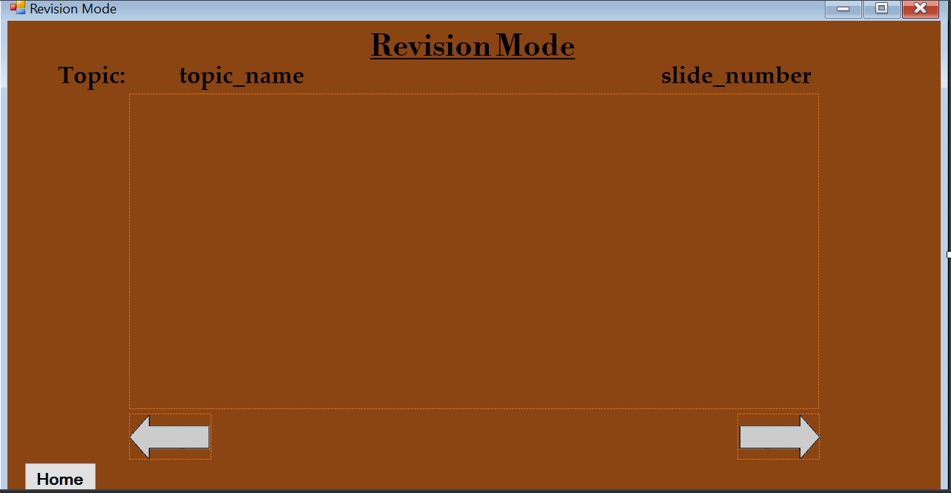

Form for the Revision Mode of the program

After having prepared the revision slides for the topic Quadratic Equations, the next thing to do is to bring in all of those slides (which I have saved as picture files) into the Resources directory of the program. This converts these images into objects which can be used by the program, and I can easily use code to work with them. To aid programming and make life easier, I also made of each slides the same size and dimension as the picture box, so that I wouldn’t have to make any adjustments in size while coding.

As stated in the design section, each topic will have a pre-set number of slides slideNumber and a counter slideCount. When the form is opened, the values of slideNumber is set to the number of slides for that selected topic (which in the case of Quadratic Equations is 13) and slideCount is set to 1. While on this, the Backwards button is disabled, so that the user can’t return and go backwards. When the forwards button is clicked, 1 is added to slideCount and the corresponding slide is shown. So long as slideCount > 1, the Backwards button is enabled, and so long as slideCount < slideNumber, the Forward button is enabled. When the Backwards button is clicked, 1 is subtracted from slideCount, and the corresponding slide is shown.

Below is my code for this:

public static int slideNumber;//preset number of slides for each topic

public static int slideCount;//counter for the slides

private void RevisionMode_Load(object sender, EventArgs e)

{

slideCount = 1;//immediately 1 because it's the first slide of the topic

Game gameValues = new Game();

switch (gameValues.selectedSubject)//going through the different possible options for selectedSubject

{

case "maths"://if maths was selected

switch (gameValues.selectedTopic)//going through the different topics

{

case "quadratic"://if the quadratic equations topic was chosen

slideNumber = 13;//there are 13 slides for the topic

QuadraticEquations();

break;

case "topic 2":

break;

case "topic 3":

break;

case "topic 4":

break;

}

break;

}

}

void QuadraticEquations()//void to display slides for the quadratic equations topic

{

slideCounter.Text = "Slide " + slideCount + " of " + slideNumber;//displaying the slide number

switch (slideCount)

{

case 1:

goBackwardBtn.Enabled = false;//disables the backwards button so you can't go back

goForwardBtn.Enabled = true;//just double-checking it is enabled :)

slideBox.Image = Properties.Resources.quadratic_slide_1;//setting image for the slide

break;

case 2:

goBackwardBtn.Enabled = true;//enables the button when on this slide :)

goForwardBtn.Enabled = true;//still making sure :)

slideBox.Image = Properties.Resources.quadratic_slide_2;//setting image for the slide

break;

case 3:

goBackwardBtn.Enabled = true;

goForwardBtn.Enabled = true;

slideBox.Image = Properties.Resources.quadratic_slide_3;//setting image for the slide

break;

case 4:

goBackwardBtn.Enabled = true;

goForwardBtn.Enabled = true;

slideBox.Image = Properties.Resources.quadratic_slide_4;//setting image for the slide

break;

case 5:

goBackwardBtn.Enabled = true;

goForwardBtn.Enabled = true;

slideBox.Image = Properties.Resources.quadratic_slide_5;//setting image for the slide

break;

case 6:

goBackwardBtn.Enabled = true;

goForwardBtn.Enabled = true;

slideBox.Image = Properties.Resources.quadratic_slide_6;//setting image for the slide

break;

case 7:

goBackwardBtn.Enabled = true;

goForwardBtn.Enabled = true;

slideBox.Image = Properties.Resources.quadratic_slide_7;//setting image for the slide

break;

case 8:

goBackwardBtn.Enabled = true;

goForwardBtn.Enabled = true;

slideBox.Image = Properties.Resources.quadratic_slide_8;//setting image for the slide

break;

case 9:

goBackwardBtn.Enabled = true;

goForwardBtn.Enabled = true;

slideBox.Image = Properties.Resources.quadratic_slide_9;//setting image for the slide

break;

case 10:

goBackwardBtn.Enabled = true;

goForwardBtn.Enabled = true;

slideBox.Image = Properties.Resources.quadratic_slide_10;//setting image for the slide

break;

case 11:

goBackwardBtn.Enabled = true;

goForwardBtn.Enabled = true;

slideBox.Image = Properties.Resources.quadratic_slide_11;//setting image for the slide

break;

case 12:

goBackwardBtn.Enabled = true;

goForwardBtn.Enabled = true;

slideBox.Image = Properties.Resources.quadratic_slide_12;//setting image for the slide

break;

case 13:

goBackwardBtn.Enabled = true;

goForwardBtn.Enabled = false;//this is the last slide so no need to keep going forward

slideBox.Image = Properties.Resources.quadratic_slide_13;//setting image for the slide

break;

}

}

private void goForwardBtn_Click(object sender, EventArgs e)

{

slideCount++;//adds one to the slide count

Game values = new Game();

switch (values.selectedSubject)//going through each subject

{

case "maths"://if maths subject was selected

switch (values.selectedTopic)//going through each topic

{

case "quadratic"://if quadratic equations topic has been selected

QuadraticEquations();//goes to the void for the quadratic equations topic

break;

}

break;

}

}

private void goBackwardBtn_Click(object sender, EventArgs e)

{

slideCount--;//removes 1 from the slide count

Game values = new Game();

switch (values.selectedSubject)//going through each subject

{

case "maths"://if maths was subject selected

switch (values.selectedTopic)//going through each topic

{

case "quadratic"://if quadratic equations topic has been selected

QuadraticEquations();//goes to the void for the quadratic equations topic

break;

}

break;

}

}

Any other topics that I do end up making revision flashcards for will follow in the same format as the one I have done above.

### **Quiz Mode**

The quiz mode consists of a brown background with a small screen to the right, where the track divided into cells is situated. On the track is the equipped avatar, which will move across the track when the user answers a question correctly. To the left is a picture box which will display the questions, and below that is a “Done” button, which the user will click after answering a question. Below that are the powerup options, where the user can use any powerup so long as they have enough in stock. At the top of the screen are the buttons to pause the game, end the game and restart the game.

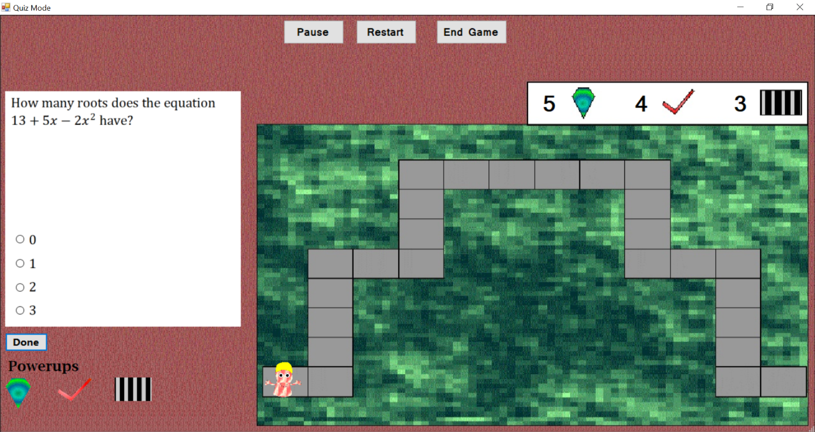

The Quiz Mode environment

In my design I had mentioned that the questions will be a mixture of objectives (with options where they would choose their answer from), writing their answers down and filling in blanks to complete partially-solved questions. However with time quickly running out, I decided that instead the questions will be purely objectives, so there will be radio buttons with which the user can select an answer. These radio buttons will remain in the same position at all times, so the different answers to the question will be at the same place. This is to avoid having to constantly move the radio buttons.

#### **Loading the Game: Explanation**

When the game form loads various activities take place. I have prepared 3 different tracks (as shown in my Design), and on loading the game, one is chosen at random. To do this, I prepared three different backgrounds, with each image being the same except for the track, and an image is set as the background image depending on which track has been randomly chosen. In my Game class, I have prepared a function that will return a random number to the PlayGame.cs file, the one that deals with the design of the form itself. The randomly generated number will then determine which track is to be selected. The number of powerups will also be fetched from the registry on loading the form, and so will the selected avatar. In addition, there is a list in the class Game called cellMoveList. In my design, I mentioned that to allow for accuracy in getting the avatar to move across the track, the total number of cells of a particular track will be broken down into 10 numbers that will all sum up to the total number of cells. When a user gets a question right, a number from a random index in the list is removed from the list and the user moves along the track the number of cells as gotten from the list.

#### **Selecting Random Questions: Explanation**

Now that the environment has been set up, the next step is to set up the questions. I have already prepared the questions for the topic Quadratic Equations, which consists of a combination from actual past exam questions from Edexcel, exam-style questions from Corbettmaths and questions that I have personally come up with myself. Each question comes with four options, with one of them being the correct answer. The user is to choose which answer they think is correct in the course of playing the game. Below is a sample of a typical question:

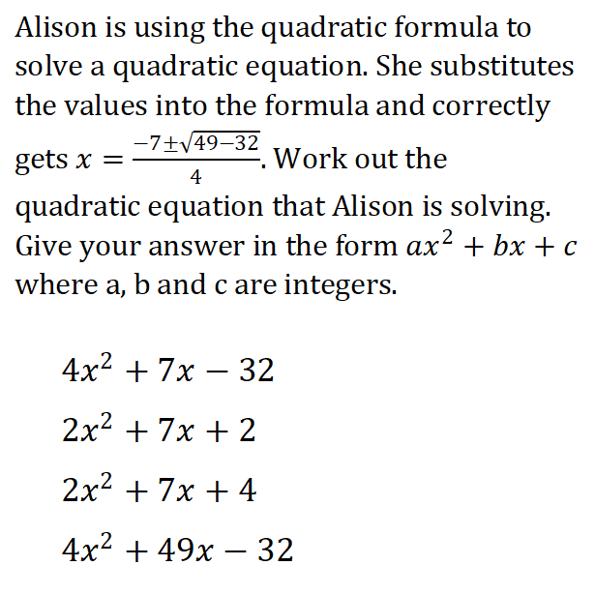

Sample revision question

My program will randomly select 10 questions from 20 already prepared questions in each game session. The user will be given three chances to get the question right before moving onto the next one. If they get the question right, then their avatar moves a random number of spaces across the track. But if they don’t get it right after all three tries have been exhausted, their avatar doesn’t move and the next question is loaded. How I have achieved this is that I have a list containing the numbers 1 through 20, and a number is randomly selected from this list. The corresponding question will be displayed, and the number is removed from the list so that the question is not brought forward again. And to answer the question, the user will select from a list of options, which I have used radio buttons to represent.

#### **Answering a Question and Moving the Avatar: Explanation**

When the Done button has been clicked, the program will look at which radio button has been selected. A function is called to return a Boolean value. If the returned value is true, then the user can advance, and the avatar is moved a random number of cells.

To get the avatar to move, timer events are called, depending on which direction the avatar is moving. There are separate timer events for if the avatar is moving right, left, down or up. But since my tracks don’t have a left direction, the only events needed are the ones for moving right, down and up. When each timer event is called, either the x or y coordinates of the avatar is changed. How this works is that the code within each event is repeatedly run in a set interval of 100 milliseconds. In the way that I have done this, when the avatar is to move right, the x position is changed by +10 once every 100 milliseconds, and then the avatar is to move up, the y position is changed by -10 (in C# Windows forms, the higher up a picture box is, the smaller its y coordinate values), and when the avatar is moving downwards its y position changes by +10 every 100 milliseconds. The timers to accomplish these are movingRightTimer, movingUpTimer and movingDownTimer.

As mentioned before, when a track is loaded, 10 integer values are assigned into cellMoveList, and these values will all sum up to the total number of cells in the track. These numbers will be picked at random when the avatar is to move across the track and will be removed from the list after being called, and these numbers are assigned to cell. However whilst doing this I realised a slight issue: when the game loads the avatar is already in the first cell, so if the user answers all questions correctly it’s only going to move the total number of cells in the track minus 1, as it is already occupying the first cell. So in an adjustment, I will make one of the numbers in cellMoveList 1 less, so that they all sum up to the total number of cells minus 1.

To make coding the movement of the avatar easier, I have prepared for myself a table with all the coordinates of the avatar in any position on all tracks, so that I know the exact possible points on the track where the avatar will be resting (i.e. not moving). To ensure the right timer event is called, I will have a set of if statements with conditions which border around different ranges of x and y coordinates where the avatar is to be moving. So for instance, if the y coordinate is constant and the x coordinate is between two different values and increasing, then movingRightTimer is to be called. Likewise, when the x coordinate is constant and the y coordinate is between two different values and increasing, then movingDownTimer is called.

Within each of the timer events, there is a switch case statement with the different possible values for cell, which is from 1 to 6. In each of these statement, I will write code for each of the possible initial locations for the avatar, and then write the next location at which the timer is to be stopped; that is, the avatar is to stop moving. So for instance, if the avatar is at X location 410, and it is to move by 3 cells to the right (hence y value is constant), when it has reached x location of 590, the timer (which in this case is movingRightTimer) is stopped, and the avatar stops moving. In the event that the avatar is going to move in more than 1 direction in a single move (for instance it’s going to move right and then move up before it stops), movingRightTimer is first called and the avatar moves the number of cells it is to move right. The timer is stopped, and the number of cells it has moved is subtracted from cell and the new value is reassigned to cell. It then calls movingUpTimer and moves the remaining cells up. So if for instance cell is 5, and the avatar is to move 2 cells to the right, and then 3 cells upward, movingRightTimer is called to move the cell 2 cells to the right. Once done, cell ← cell – 2, which now makes cell 3, and movingRightTimer is stopped. movingUpTimer is then called to move the avatar 3 cells up, before the avatar stops moving altogether completely. If an avatar is done moving, the NextStep() procedure is called. If questionCount is less than 10, it brings forward the next question. If it’s equal to 10 or the user has clicked on the End Game button, it ends the game.

After doing this, I noticed that I was repeating code several times, and this made my total lines of code very large. The basic issue is that there was a constant repetition of the lines cell = cell – 1 (basically points where the avatar had to move in more than 1 direction and a different timer was needed to be run, so the number of cells the avatar had moved was subtracted from the total number of cells and then the next timer was started, for instance if the avatar was to move by 5 cells and was to move by 2 cells to the right and 3 cells up), movingRightTimer.Start(),movingRightTimer.Stop(), movingUpTimer.Start(),movingUpTimer.Stop(),MovingDownTimer.Start() and movingDownTimer.Stop(). In an effort to solve this and make my code more efficient, I created two more voids called ContinueMovement() and StopTimers(). ContinueMovement() was called every time a case was met, with Boolean variables and an integer variable being passed on. There were three Boolean variables movingRight, movingDown and movingUp, and the integer value was remainingCells. If the avatar were to just stop moving (that is, it didn’t need to move in another direction), all the Boolean values passed on were false, and remainingCells was 0. But if the avatar needed to continue moving in a different direction, take for instance downwards, movingDown was made true, and the remaining Boolean values were false. Then the total remaining cells left for the avatar to move were passed on to remainingCells. StopTimers() is run at the beginning of ContinueMovement(), and this stops any active timer.

#### **Using the Powerups: Explanation**

There are three buttons below the Done button which are for the using of each of the powerups: the Hint Gem, the Question Skipper and the Fast Track. The Hint Gem allows the user to get a hint to aid their solving of the question and can be used an infinite number of times so long as the user has enough gems. The Question Skipper allows the user to skip a question if they should find it difficult and can be used only twice in a game session. The Fast Track allows the user to skip two questions and move along the track twice (as though they got those two questions correct), making them to answer only 8 questions without them worrying about losing coins. This can only be used once in a game session.

When each button is clicked to use the powerup, the user is asked to confirm if they actually wanted to use the powerup, in the event that they clicked on the button by accident or clicked on it too quickly. When the user has confirmed that they do want to use the powerup, it is then equipped, and 1 is removed from the total number of that powerup that they have and stored in the registry.

If the user is using a Hint Gem, after confirming that they do want to use it, 1 is added to usedGemTotal, which will eventually display the total Hint Gems used throughout the course of playing that game session. Then 1 will be removed from gemTotal with the new value being written into the registry. A dialog window will then be displayed to show the hint. The user will click on a button which says Thanks, which will close the window. When the window is closed, the new total number of Hint Gems will then be displayed on the game screen.

If the user is to use the Question Skipper, a dialog box will ask them they really want to use it, showing them the total number of uses they have left (since they can only use it twice). After the user has confirmed that they’re using the Question Skipper, if they have enough uses left, the SelectRandomQuestions() procedure is called. This is the same procedure that is called every time a question is to be selected, and this selects a new random question for the user so they can skip the current question they’re on if it’s too difficult for them. This doesn’t affect the total number of questions they’ve answered, the ones they’ve gotten correctly, the ones they got wrongly or the total number of coins they’ve earned.

If the Fast Track is to be equipped, the user is prompted that they can only use it this once in the game session. If they go ahead to use the avatar, it calls the MoveAvatar() procedure, which handles which timer to start to move the avatar, depending on it’s current position and the track that is currently in use. At the same time, another timer usingFastTrack is called. This timer runs while the avatar is moving. Once the avatar stops moving, the timer is stopped, and MoveAvatar() is called again to move the avatar for a second time. When the avatar is done moving, the next question is loaded.

#### **Ending the Game and the Pause and Restart System: Explanation**

When the user has answered all questions, and questionCount == 10, the game is stopped. A message box appears to display the result of the game session, and this displays the total number of coins earned in that session, the total number of questions answered correctly, the total number of questions answered wrongly and the total powerups used. To calculate the total number of coins, when a question has been answered correctly and cell has been assigned, right before the moving of the avatar, totalCoinsEarned = totalCoinsEarned + cell. At the end of the game, the final total coins become the sum of the total spaces moved across the track, 2 multiplied the total questions answered correctly and 4 multiplied by the total questions answered correctly on the first try. The new total is displayed in the message box, and the new total is added to the number of coins already stored in the registry. Afterwards, the game form is closed and the main menu form is loaded.

When the “Pause” button is clicked, a dialog box appears telling the user that the game is paused. The user can only continue playing when they click OK.

When the “Restart” button is clicked, the user is prompted first that they will lose all of their current. If the user goes ahead to restart the game, all the procedures run when the PlayGame form is loaded are rerun, which sets all variables to their default values, picks another track at random and selects another random question. The user is then prompted that they have restarted the game.

When the “End Game” button is clicked, the user is alerted that this will end their current progress. If the user goes ahead, the game is ended, with the dialog box displaying their results. Afterwards the form is then closed and the main menu loaded.

Below is the code for various aspects of the procedure:

#### **Game class: Code**

public static string selectedSubject;//identifier for different subjects

public static string selectedTopic;//value to store the chosen topic

public static string selectedMode;//identifier for the revision mode

public static int firstTryAnswers;//number of quesions the user answered correctly on first try

public static int correctAnswers;//number of questions the user answered correctly

public static int wrongAnswers;//number of questions the user answered wrongly

public static int totalCoinsEarned;//total number of coins earned by the user

public static string questionIdentifier;//a string identifier for each question

public static int triesNumber;//total number of tries by the user on attempting to answer a question, default value is 0

public static List<int> questionList = new List<int> { };//list to contain question numbers, set when PlayGame loads

public static int questionCount;//counts the number of questions answered by the user

public static List<int> cellMoveList = new List<int> { };//list for the number of cells the avatar is going to move,

//which will all total to the total number of cells in each track. initially empty; assigned when a track is randomly chosen

public static int skipperUseCount;//the number of times the question skipper is used

public static bool fastTrackUsed;//a bool to determine if the fast track has been used

public static int usedGemTotal;//stores the total number of gems that are used in a game session

public int randomTrackNumber()//to generate a random number of tracks

{

Random rnd = new Random();

return rnd.Next(1, 4);//at the moment I have currently have 3 tracks so it will randomly select one from either 3

}

public void SettingDefaultValues()//void to set the default values; called whenever the form is loaded

{

questionCount = 0;//sets the default value of answered questions to 0, as the questions won't start to be answered until one has been displayed

//whereby it will now become 1

triesNumber = 0;//sets the value to 0 by default

totalCoinsEarned = 0;//set to 0 by default

firstTryAnswers = 0;//set to 0 by default

correctAnswers = 0;//set to 0 by default

wrongAnswers = 0;//set to 0 by default

skipperUseCount = 0;//set to 0 by default

usedGemTotal = 0;//setting this value to 0 by default

fastTrackUsed = false;//set to false by default

cellMoveList = new List<int> { };//set to null by default

questionList = new List<int> { 1, 2, 3, 4, 5, 6, 7, 8, 9, 10, 11, 12, 13, 14, 15, 16, 17, 18, 19, 20 };//sets the values for questionList

}

public int randomCellNumber()//determines a random number to be selected from cellMoveList

{

Random rnd = new Random();

int number = cellMoveList[rnd.Next(0, cellMoveList.Count - 1)];//gets the number from a random index point

cellMoveList.Remove(number);//removes the selected number from the list

return number;

}

public bool AddingResults(bool correct)

{

if (triesNumber < 3)//if the user hasn't yet exhausted 3 tries

{

if (triesNumber == 1 && correct == true)//if answer is correct on first try

{

firstTryAnswers++;//adds one to firstTryAnswers

correctAnswers++;//adds 1 to correctAnswers

MessageBox.Show("Correct! Well done!", "Correct!", MessageBoxButtons.OK, MessageBoxIcon.Information);

questionCount++;//the question has been answered so adds 1

return true;

}

else if (correct == true)

{

correctAnswers++;//adds 1 to correctAnswers

MessageBox.Show("Correct! Well done!", "Correct!", MessageBoxButtons.OK, MessageBoxIcon.Information);

questionCount++;//the question has been answered so adds 1

return true;

}

else if (correct == false)

{

MessageBox.Show("Sorry, not quite right. Don't worry, you still have " + (3 - triesNumber).ToString() +

" tries left.", "Incorrect answer", MessageBoxButtons.OK, MessageBoxIcon.Information);//displays the end result

return false;

}

}

else//once triesNumber == 3

{

if (correct == true)

{

correctAnswers++;//adds 1 to correctAnswers

MessageBox.Show("Correct! Well done!", "Correct!", MessageBoxButtons.OK, MessageBoxIcon.Information);

questionCount++;//the question has been answered so adds 1

return true;

}

else

{

wrongAnswers++;//adds 1 to wrong answers as user has exhausted all 3 tries without getting the answer right

MessageBox.Show("Sorry, still not quite right :( Hopefully you'll do better next time!", "Still wrong...", MessageBoxButtons.OK, MessageBoxIcon.Information);

questionCount++;//the question has been answered (even though wrongly) so adds 1

//so time to go of to the next question but the avatar is NOT going

return false;

}

}

return false;

}//this is to add the results and display appropriate message

public int AddCoins()//void to add the total coins

{

int previousCoins = int.Parse(ReadFromRegistry(CoinKey()));//getting the former total of coins from the registry

totalCoinsEarned = totalCoinsEarned + (2 * correctAnswers) + (4 * firstTryAnswers);//determining the total of coins earned

previousCoins = previousCoins + totalCoinsEarned;//adding the new value of earned coins to previousCoins

WriteIntoRegistry(CoinKey(), previousCoins.ToString());//writing the new value of total earned coins into the registry

return totalCoinsEarned;

}

public void DisplayEndResults()//void to display the end results of the game

{

string information;//a string to display the information of the game session.

information = "Total coins earned: " + AddCoins().ToString() + "\nQuestions answered correctly: "

+ correctAnswers.ToString() + "\nQuestions answered wrongly: " + wrongAnswers.ToString() + "\nTotal" +

" Hint Gems used: " + usedGemTotal.ToString() + "\nTotal Questions Skippers used: " + skipperUseCount.ToString()

+ "\nFast Track used: ";//determining the value in information

if (fastTrackUsed == true)//if it was used

{

information = information + "yes";//adding that to the string value if it was used

}

else//if it wasn't used

{

information = information + "no";//adding that to the string value if it wasn't used

}

System.Threading.Thread.Sleep(1000);

MessageBox.Show(information, "GAME FINISHED!", MessageBoxButtons.OK, MessageBoxIcon.Information);//message box to display the information

}

#### **Loading the Game: Code**

public int trackID;//variable to hold the random number generated for the track to be used

public int cell;//variable to hold the number of cells the avatar is to move

public int originalX;//variable to store the original x coordinate of the picture box

public int originalY;//variable to store the original y coordinate of the picture box

public bool stoppedMoving;//bool to determine when the avatar has stopped moving and the next question can be loaded

//setting up the initial display

private void QuizMode_Load(object sender, EventArgs e)

{

Game gameValues = new Game();

gameValues.SettingDefaultValues();//runs the void in the Game class to set the default values

Arrangements();

DetermineTrack(gameValues);

DetermineAvatar(gameValues);

FetchPowerups(gameValues);

System.Threading.Thread.Sleep(500);//sleeps by 500ms

MessageBox.Show("Welcome, " + gameValues.ReadFromRegistry(gameValues.UserKey()) + ", to the Quiz Mode! Test yourself and your knowledge and see if you're smart enough to escape the forest! The rules of the game are simple: answer a question and if you're right, your avatar moves forward along the track! Answer all 10 questions correctly, and you're out! You can use powerups to help you should the peril of the journey prove more unbearable than expected. All the best!", "Welcome to The Quiz Mode", MessageBoxButtons.OK, MessageBoxIcon.Information);

SelectRandomQuestions();

}

private void Arrangements()//arranges the elements in the form; not really important, just to keep the code tidy :)

{

gemNumber.Location = new Point(845, 120);//positins the gem number label

questionSkipNumber.Location = new Point(990, 120);//positions the question skipper number label

fastTrackNumber.Location = new Point(1145, 120);//positions the fast track number label

questionPictureBox.Size = new Size(370, 370);//sets the size of the question picture box

questionPictureBox.Location = new Point(8, 120);//sets the location of the question picture box

btn_DoneNext.Location = new Point(8, 500);//sets the location of the done button

label1.Location = new Point(8, 540);//sets the location of the "Powerups" text

hintGemActivate.Location = new Point(8, 570);//sets the location of the hint gem activation button

questionSkipperActivate.Location = new Point(90, 570);//sets the location of the question skipper activation button

fastTrackActivate.Location = new Point(180, 570);//sets the location of the fast track activation button

optionA.Location = new Point(25, 346);//sets the position of radio button 1

optionB.Location = new Point(25, 384);//sets the position of radio button 2

optionC.Location = new Point(25, 422);//sets the position of radio button 3

optionD.Location = new Point(25, 458);//sets the position of radio button 4

}

private void DetermineTrack(Game gameValues)//this determines which track is used for a particular game session

{

trackID = gameValues.randomTrackNumber();//assigns the random number here to be used by the program

switch (trackID)

{

case 1:

this.BackgroundImage = Properties.Resources.background_with_track_1;//selects the background with track 1

avatarPictureBox.Location = new Point(410, 476);//positions the avatar at the start point of this track

Game.cellMoveList = new List<int> { 2, 3, 1, 5, 2, 3, 6, 2, 4, 2 };//assigns the random number of cells

//in here which will total up to the number of cells in this track minus 1, which is 31-1=30

break;

case 2:

this.BackgroundImage = Properties.Resources.background_with_track_2;//selects the background with track 2

avatarPictureBox.Location = new Point(430, 300);//positions the avatar at the start point of this track

Game.cellMoveList = new List<int> { 3, 2, 4, 5, 2, 6, 3, 5, 3, 2 };//in this case all numbers sum up to 36-1=35

break;

case 3:

this.BackgroundImage = Properties.Resources.background_with_track_3;//selects the background with track 3

avatarPictureBox.Location = new Point(415, 545);//positions the avatar at the start point of this track

Game.cellMoveList = new List<int> { 1, 3, 2, 1, 2, 4, 3, 2, 4, 3 };//in this case all numbers add up to 26-1=25

break;

}

}

private void DetermineAvatar(Game gameValues)//selects the avatar to be displayed

{

if (bool.Parse(gameValues.ReadFromRegistry(gameValues.CasualEquipped())) == true)//if the casual player is equipped

{

avatarPictureBox.Image = Properties.Resources.casual_player_icon;//displays the casual player

}

else if (bool.Parse(gameValues.ReadFromRegistry(gameValues.KoolEquipped())) == true)//if the kool kid is equipped

{

avatarPictureBox.Image = Properties.Resources.kool_kid_icon;//displays the kool kid

}

else if (bool.Parse(gameValues.ReadFromRegistry(gameValues.FunEquipped())) == true)//if the fun guy is equipped

{

avatarPictureBox.Image = Properties.Resources.fun_guy_icon;//displays the fun guy

}

}

private void FetchPowerups(Game gameValues)//fetches the values of each powerup into the game environment

{

gemNumber.Text = gameValues.ReadFromRegistry(gameValues.HintTotal());//fetches the number of hint gems from the registry

questionSkipNumber.Text = gameValues.ReadFromRegistry(gameValues.SkipTotal());//fetches the number of question skippers from the registry

fastTrackNumber.Text = gameValues.ReadFromRegistry(gameValues.FastTotal());//fetches the number of fast track powerups from the registry

}

#### **Selecting a Random Question: Code**

//setting up the questions

private void SelectRandomQuestions()//to randomly select a question

{

optionA.Checked = false;

optionB.Checked = false;

optionC.Checked = false;

optionD.Checked = false;//unchecks all the radio buttons so as to not confuse the user as the previously checked radio

//button remains checked

btn_DoneNext.Enabled = true;//enables the Done button if in the event it has been disabled by the moving of the avatar

int randomQuestion;//stores the number for the randomly selected question

Random rnd = new Random();

randomQuestion = Game.questionList[rnd.Next(0, Game.questionList.Count - 1)];

Game.questionList.Remove(randomQuestion);

DisplayQuestions(randomQuestion);

}

private void DisplayQuestions(int randomQuestion)

{

Game.triesNumber = 0;//sets this to 0

switch (randomQuestion)//to switch between different question numbers

{

case 1://if it's question 1

switch (Game.selectedTopic)

{

case "quadratic":

Game.questionIdentifier = "quad1";//identifier for question 1 for quadratic equations; used in the Answers() void

questionPictureBox.Image = Properties.Resources.quadratic_question_1;//brings question 1 for quadratic equations

break;

}

break;

case 2://if it's question 2

switch (Game.selectedTopic)

{

case "quadratic":

Game.questionIdentifier = "quad2";//identifier for question 2 for quadratic equations; used in the Answers() void and so on...

questionPictureBox.Image = Properties.Resources.quadratic_question_2;//brings question 2 for quadratic equations

break;

}

break;

case 3://if it's question 3 and so on...

switch (Game.selectedTopic)

{

case "quadratic":

Game.questionIdentifier = "quad3";

questionPictureBox.Image = Properties.Resources.quadratic_question_3;//brings question 3 for quadratic equations and so on

break;

}

break;

case 4:

switch (Game.selectedTopic)

{

case "quadratic":

Game.questionIdentifier = "quad4";

questionPictureBox.Image = Properties.Resources.quadratic_question_4;

break;

}

break;

case 5:

switch (Game.selectedTopic)

{

case "quadratic":

Game.questionIdentifier = "quad5";

questionPictureBox.Image = Properties.Resources.quadratic_question_5;

break;

}

break;

case 6:

switch (Game.selectedTopic)

{

case "quadratic":

Game.questionIdentifier = "quad6";

questionPictureBox.Image = Properties.Resources.quadratic_question_6;

break;

}

break;

case 7:

switch (Game.selectedTopic)

{

case "quadratic":

Game.questionIdentifier = "quad7";

questionPictureBox.Image = Properties.Resources.quadratic_question_7;

break;

}

break;

case 8:

switch (Game.selectedTopic)

{

case "quadratic":

Game.questionIdentifier = "quad8";

questionPictureBox.Image = Properties.Resources.quadratic_question_8;

break;

}

break;

case 9:

switch (Game.selectedTopic)

{

case "quadratic":

Game.questionIdentifier = "quad9";

questionPictureBox.Image = Properties.Resources.quadratic_question_9;

break;

}

break;

case 10:

switch (Game.selectedTopic)

{

case "quadratic":

Game.questionIdentifier = "quad10";

questionPictureBox.Image = Properties.Resources.quadratic_question_10;

break;

}

break;

case 11:

switch (Game.selectedTopic)

{

case "quadratic":

Game.questionIdentifier = "quad11";

questionPictureBox.Image = Properties.Resources.quadratic_question_11;

break;

}

break;

case 12:

switch (Game.selectedTopic)

{

case "quadratic":

Game.questionIdentifier = "quad12";

questionPictureBox.Image = Properties.Resources.quadratic_question_12;

break;

}

break;

case 13:

switch (Game.selectedTopic)

{

case "quadratic":

Game.questionIdentifier = "quad13";

questionPictureBox.Image = Properties.Resources.quadratic_question_13;

break;

}

break;

case 14:

switch (Game.selectedTopic)

{

case "quadratic":

Game.questionIdentifier = "quad14";

questionPictureBox.Image = Properties.Resources.quadratic_question_14;

break;

}

break;

case 15:

switch (Game.selectedTopic)

{

case "quadratic":

Game.questionIdentifier = "quad15";

questionPictureBox.Image = Properties.Resources.quadratic_question_15;

break;

}

break;

case 16:

switch (Game.selectedTopic)

{

case "quadratic":

Game.questionIdentifier = "quad16";

questionPictureBox.Image = Properties.Resources.quadratic_question_16;

break;

}

break;

case 17:

switch (Game.selectedTopic)

{

case "quadratic":

Game.questionIdentifier = "quad17";

questionPictureBox.Image = Properties.Resources.quadratic_question_17;

break;

}

break;

case 18:

switch (Game.selectedTopic)

{

case "quadratic":

Game.questionIdentifier = "quad18";

questionPictureBox.Image = Properties.Resources.quadratic_question_18;

break;

}

break;

case 19:

switch (Game.selectedTopic)

{

case "quadratic":

Game.questionIdentifier = "quad19";

questionPictureBox.Image = Properties.Resources.quadratic_question_19;

break;

}

break;

case 20:

switch (Game.selectedTopic)

{

case "quadratic":

Game.questionIdentifier = "quad20";

questionPictureBox.Image = Properties.Resources.quadratic_question_20;

break;

}

break;

}

}

#### **Determining the Answer: Code**

//determining answers

private void btn_DoneNext_Click(object sender, EventArgs e)//when the Done button is clicked

{

Game.triesNumber++;//adds one to triesNumber

MarkAnswer();

}

public void MarkAnswer()//marks the questions

{

bool correct = false;//the boolean to determine if the answer is correct or not

Game gameValues = new Game();//creating object for Game

switch (Game.questionIdentifier)//going through

{

case "quad1"://if the previous

if (optionC.Checked == true)//option C is the correct answer for quad1

{

correct = true;

}

break;

case "quad2":

if (optionB.Checked == true)

{

correct = true;

}

break;

case "quad3":

if (optionB.Checked == true)

{

correct = true;

}

break;

case "quad4":

if (optionC.Checked == true)

{

correct = true;

}

break;

case "quad5":

if (optionD.Checked == true)

{

correct = true;

}

break;

case "quad6":

if (optionC.Checked == true)

{

correct = true;

}

break;

case "quad7":

if (optionC.Checked == true)

{

correct = true;

}

break;

case "quad8":

if (optionB.Checked == true)

{

correct = true;

}

break;

case "quad9":

if (optionB.Checked == true)

{

correct = true;

}

break;

case "quad10":

if (optionB.Checked == true)

{

correct = true;

}

break;

case "quad11":

if (optionD.Checked == true)

{

correct = true;

}

break;

case "quad12":

if (optionA.Checked == true)

{

correct = true;

}

break;

case "quad13":

if (optionD.Checked == true)

{

correct = true;

}

break;

case "quad14":

if (optionA.Checked == true)

{

correct = true;

}

break;

case "quad15":

if (optionC.Checked == true)

{

correct = true;

}

break;

case "quad16":

if (optionB.Checked == true)

{

correct = true;

}

break;

case "quad17":

if (optionA.Checked == true)

{

correct = true;

}

break;

case "quad18":

if (optionD.Checked == true)

{

correct = true;

}

break;

case "quad19":

if (optionB.Checked == true)

{

correct = true;

}

break;

case "quad20":

if (optionD.Checked == true)

{

correct = true;

}

break;

}//determines if the user got the answer

if (gameValues.AddingResults(correct) == true)

{

btn_DoneNext.Enabled = false;//disables this button so the user makes no action while the avatar is moving

MoveAvatar(gameValues, false);

Game.triesNumber = 0;//sets this back to default)

}

else

{

if (Game.triesNumber == 3)//if AddingResults() is false and all tries have been exhausted

{

Game.triesNumber = 0;//sets this back to default

NextStep(false);

}

}

}

public void NextStep(bool gameEnded)//going to the next step after a question has been answered

{

Game gameValues = new Game();

if (Game.questionCount == 10 || gameEnded == true)//if 10 questions have been answered or the game was ended

{

gameValues.DisplayEndResults();//calls this void to display the end results

this.Close();//closes this form

}

else if (Game.questionCount < 10 && usingFastTrack.Enabled == false)//if 10 questions haven't been answered yet by the user and the fast track isn't in use

{

System.Threading.Thread.Sleep(500);

SelectRandomQuestions();

}

}

#### **Moving the Avatar: Code**

//moving the avatar

private void MoveAvatar(Game gameValues, bool fastTrackUsed)

{

stoppedMoving = false;//assigns the value of false so that it is changed from true before the avatar is moved again

cell = gameValues.randomCellNumber();//gets the random number

Game.totalCoinsEarned = Game.totalCoinsEarned + cell;//adds the randomly generated cell number to the total of coins earned

if (fastTrackUsed == false)//if the Fast Track is not in use

{

MessageBox.Show("Congratulations on getting this question right! Now you get to move " + cell.ToString() + " cells across the track!",

"Move along!", MessageBoxButtons.OK, MessageBoxIcon.Information);

}

originalX = avatarPictureBox.Location.X;//x position of the picture box

originalY = avatarPictureBox.Location.Y;//y position of the picture

switch (trackID)//depending on which track is in use

{

case 1://if track 1 is in use

if ((originalX >= 410 && originalX < 590 && originalY == 476) || (originalX >= 590 && originalX < 960 && originalY == 306) || (originalX >= 960 && originalX < 1200 && originalY == 536))

//determining the positions at which the avatar is to move to the right

{

movingRightTimer.Start();//starts the event which will enable the avatar to move to the right

}

else if ((originalX == 590 && originalY <= 476 && originalY > 306) || (originalX == 1200 && originalY <= 536 && originalY > 366))

//determining the positions at which the avatar is to move up

{

movingUpTimer.Start();//starts the event which will enable the avatar to move up

}

else if ((originalX == 960 && originalY >= 306 && originalY < 536))

//determining the positions at which the avatar is to move down

{

movingDownTimer.Start();//starts the event which will enable the avatar to move down

}

break;

case 2://if track 2 is in use

if ((originalX >= 430 && originalX < 560 && originalY == 300) || (originalX >= 560 && originalX < 840 && originalY == 580) || (originalX >= 840 && originalX < 1120 && originalY == 180) || (originalX == 1120 && originalY == 550))

//positions of the avatar at which it is to move to the right

{

movingRightTimer.Start();

}

else if ((originalX == 560 && originalY >= 300 && originalY < 580) || (originalX == 1120 && originalY >= 180 && originalY < 550))

//positions of the avatar at which it is to move down

{

movingDownTimer.Start();

}

else if ((originalX == 840 && originalY <= 580 && originalY > 180))

{

movingUpTimer.Start();

}

break;

case 3://if track 3 is in use

if ((originalX == 415 && originalY == 545) || (originalY == 365 && originalX >= 495 && originalX < 635) || (originalX >= 635 && originalX < 985 && originalY == 215) || (originalX >= 985 && originalX < 1125 && originalY == 355) || (originalX == 1125 && originalY == 545))

{

movingRightTimer.Start();

}

else if ((originalX == 985 && originalY >= 215 && originalY < 355) || (originalX == 1125 && originalY >= 355 && originalY < 545))

{

movingDownTimer.Start();

}

else if ((originalX == 495 && originalY <= 545 && originalY > 365) || (originalX == 635 && originalY <= 365 && originalY > 215))

{

movingUpTimer.Start();

}

break;

}

}

private void ContinueMovement(bool movingRight, bool movingUp, bool movingDown, int remainingCells)//this is to continue the movement

//depending on which direction the avatar is to continue moving

{

StopTimers();//calls this to stop the current timer in use

cell = remainingCells;//assigns the remaining number of cells to cell

if (movingRight == true && movingUp == false && movingDown == false)//if the avatar is to continue by moving right

{

movingRightTimer.Start();//starts this timer

}

else if (movingRight == false && movingUp == true && movingDown == false)//if the avatar is to continue by moving up

{

movingUpTimer.Start();//starts this timer

}

else if (movingRight == false && movingUp == false && movingDown == true)//if the avatar is to continue by moving down

{

movingDownTimer.Start();

}

else//if the avatar is to just stop moving

{

stoppedMoving = true;//sets this to true

NextStep(false);

}

}

public void StopTimers()//this is just to stop the timers

{

originalX = avatarPictureBox.Location.X;//sets the new x-location to originalX

originalY = avatarPictureBox.Location.Y;//sets the new y-location to originalY

stoppedMoving = false;//sets this to false by default, is set to true if the avatar has stopped moving

if (movingRightTimer.Enabled == true)//if movingRightTimer is currently in use

{

movingRightTimer.Stop();

}

else if (movingUpTimer.Enabled == true)//if movingUpTimer is currently in use

{

movingUpTimer.Stop();

}

else if (movingDownTimer.Enabled == true)//if movingUpTimer is currently in use

{

movingDownTimer.Stop();

}

}

(because the code in the timers which handle the actual movement of the avatar is very long, I will only display a bit of it from each timer so as to give an idea of what the code is like)

This is for movingRightTimer:

private void movingRightTimer_Tick(object sender, EventArgs e)//timer for moving the avatar to the right

{

int x = avatarPictureBox.Location.X;

int y = avatarPictureBox.Location.Y;//setting the x and y co-ordinates

avatarPictureBox.Location = new Point(x + 10, y);//moves the avatar to the right by increasing its x coordinate value

switch (cell)//switching between all the possible numbers that could be assigned to cell, which is 1 through 6

{

case 1://if 1 is assigned to cell

switch (trackID)

{

case 1:

switch (originalX)

{

case 410:

if (avatarPictureBox.Location.X == 480)

{

ContinueMovement(false, false, false, 0);

}

break;

case 480:

if (avatarPictureBox.Location.X == 530)

{

ContinueMovement(false, false, false, 0);

}

break;

case 530:

if (avatarPictureBox.Location.X == 590)

{

ContinueMovement(false, false, false, 0);

}

break;

case 590:

if (avatarPictureBox.Location.X == 630)

{

ContinueMovement(false, false, false, 0);

}

break;

case 630:

if (avatarPictureBox.Location.X == 710)

{

ContinueMovement(false, false, false, 0);

}

break;

case 710:

if (avatarPictureBox.Location.X == 750)

{

ContinueMovement(false, false, false, 0);

}

break;

case 750:

if (avatarPictureBox.Location.X == 790)

{

ContinueMovement(false, false, false, 0);

}

break;

case 790:

if (avatarPictureBox.Location.X == 830)

{

ContinueMovement(false, false, false, 0);

}

break;

case 830:

if (avatarPictureBox.Location.X == 870)

{

ContinueMovement(false, false, false, 0);

}

break;

case 870:

if (avatarPictureBox.Location.X == 910)

{

ContinueMovement(false, false, false, 0);

}

break;

case 910:

if (avatarPictureBox.Location.X == 960)

{

ContinueMovement(false, false, false, 0);

}

break;

case 960:

if (avatarPictureBox.Location.X == 1020)

{

ContinueMovement(false, false, false, 0);

}

break;

case 1020:

if (avatarPictureBox.Location.X == 1080)

{

ContinueMovement(false, false, false, 0);

}

break;

case 1080:

if (avatarPictureBox.Location.X == 1140)

{

ContinueMovement(false, false, false, 0);

}

break;

case 1140:

if (avatarPictureBox.Location.X == 1200)

{

ContinueMovement(false, false, false, 0);

}

break;

}

break;

case 2://1 may not exist in cellMoveList for track 2, but however it might still need to move 1 cell to

//complete a previously started movement so this will be needed as well

switch (originalX)

{//showing only the possible values of originalX at where it will need to complete a movement with 1 cell left

case 560:

if (avatarPictureBox.Location.X == 630)

{

ContinueMovement(false, false, false, 0);//goes here to determine that the timer is to be stopped

}

break;

case 840:

if (avatarPictureBox.Location.X == 910)

{

ContinueMovement(false, false, false, 0);

}

break;

case 1120:

if (avatarPictureBox.Location.X == 1190)

{

ContinueMovement(false, false, false, 0);

}

break;

}

break;

case 3:

switch (originalX)

{

case 415:

if (avatarPictureBox.Location.X == 495)

{

ContinueMovement(false, false, false, 0);//goes here to determine that the timer is to be stopped

}

break;

case 495:

if (avatarPictureBox.Location.X == 565)

{

ContinueMovement(false, false, false, 0);

}

break;

case 565:

if (avatarPictureBox.Location.X == 635)

{

ContinueMovement(false, false, false, 0);

}

break;

case 635:

if (avatarPictureBox.Location.X == 705)

{

ContinueMovement(false, false, false, 0);

}

break;

case 705:

if (avatarPictureBox.Location.X == 775)

{

ContinueMovement(false, false, false, 0);

}

break;

case 775:

if (avatarPictureBox.Location.X == 845)

{

ContinueMovement(false, false, false, 0);

}

break;

case 845:

if (avatarPictureBox.Location.X == 915)

{

ContinueMovement(false, false, false, 0);

}

break;

case 915:

if (avatarPictureBox.Location.X == 985)

{

ContinueMovement(false, false, false, 0);

}

break;

case 985:

if (avatarPictureBox.Location.X == 1055)

{

ContinueMovement(false, false, false, 0);

}

break;

case 1055:

if (avatarPictureBox.Location.X == 1125)

{

ContinueMovement(false, false, false, 0);

}

break;

case 1125:

if (avatarPictureBox.Location.X == 1205)

{

ContinueMovement(false, false, false, 0);

}

break;

}

break;

}

break;

}

}

This is for movingDownTimer:

private void movingDownTimer_Tick(object sender, EventArgs e)//timer for moving avatar down

{

int x = avatarPictureBox.Location.X;

int y = avatarPictureBox.Location.Y;//setting the x and y co-ordinates

avatarPictureBox.Location = new Point(x, y + 10);//moves the avatar to the right by increasing its y coordinate value

switch (cell)//switching between all the possible numbers that could be assigned to cell, which is 1 through 6

{

case 1:

switch (trackID)

{

case 1:

switch (originalY)

{

case 306:

if (avatarPictureBox.Location.Y == 346)

{

ContinueMovement(false, false, false, 0);

}

break;

case 346:

if (avatarPictureBox.Location.Y == 386)

{

ContinueMovement(false, false, false, 0);

}

break;

case 386:

if (avatarPictureBox.Location.Y == 426)

{

ContinueMovement(false, false, false, 0);

}

break;

case 426:

if (avatarPictureBox.Location.Y == 466)

{

ContinueMovement(false, false, false, 0);

}

break;

case 466:

if (avatarPictureBox.Location.Y == 496)

{

ContinueMovement(false, false, false, 0);

}

break;

case 496:

if (avatarPictureBox.Location.Y == 536)

{

ContinueMovement(false, false, false, 0);

}

break;

}

break;

case 2://1 doesn't show up in cellMoveList for track 2, but there is an instance at which the avatar will need

//to move down by one cell to complete a previous movement so I'll include it in here as well

switch (originalY)

{

case 300:

if (avatarPictureBox.Location.Y == 350 && avatarPictureBox.Location.X == 560)

{

ContinueMovement(false, false, false, 0);

}

else if (avatarPictureBox.Location.Y == 340 && avatarPictureBox.Location.X == 1120)

{

ContinueMovement(false, false, false, 0);

}

break;

case 180:

if (avatarPictureBox.Location.Y == 220)

{

ContinueMovement(false, false, false, 0);

}

break;

}

break;

case 3:

switch (originalY)

{

case 215:

if (avatarPictureBox.Location.Y == 265)

{

ContinueMovement(false, false, false, 0);

}

break;

case 265:

if (avatarPictureBox.Location.Y == 315)

{

ContinueMovement(false, false, false, 0);

}

break;

case 315:

if (avatarPictureBox.Location.Y == 355)

{

ContinueMovement(false, false, false, 0);

}

break;

case 355:

if (avatarPictureBox.Location.Y == 405)

{

ContinueMovement(false, false, false, 0);

}

break;

case 405:

if (avatarPictureBox.Location.Y == 455)

{

ContinueMovement(false, false, false, 0);

}

break;

case 455:

if (avatarPictureBox.Location.Y == 495)

{

ContinueMovement(false, false, false, 0);

}

break;

case 495:

if (avatarPictureBox.Location.Y == 545)

{

ContinueMovement(false, false, false, 0);

}

break;

}

break;

}

break;

}

}

This is for movingUpTimer:

private void movingUpTimer_Tick(object sender, EventArgs e)//timer for moving up

{

int x = avatarPictureBox.Location.X;

int y = avatarPictureBox.Location.Y;//setting the x and y co-ordinates

avatarPictureBox.Location = new Point(x, y - 10);//moves the avatar to the right by decreasing its y coordinate value

switch (cell)//switching between all the possible numbers that could be assigned to cell, which is 1 through 6

{

case 1:

switch (trackID)

{

case 1:

switch (originalY)

{

case 476:

if (avatarPictureBox.Location.Y == 436)

{

ContinueMovement(false, false, false, 0);

}

break;

case 436:

if (avatarPictureBox.Location.Y == 396)

{

ContinueMovement(false, false, false, 0);

}

break;

case 396:

if (avatarPictureBox.Location.Y == 356)

{

ContinueMovement(false, false, false, 0);

}

break;

case 356:

if (avatarPictureBox.Location.Y == 306)

{

ContinueMovement(false, false, false, 0);

}

break;

case 536:

if (avatarPictureBox.Location.Y == 496)

{

ContinueMovement(false, false, false, 0);

}

break;

case 496:

if (avatarPictureBox.Location.Y == 456)

{

ContinueMovement(false, false, false, 0);

}

break;

case 456:

if (avatarPictureBox.Location.Y == 416)

{

ContinueMovement(false, false, false, 0);

}

break;

case 416:

if (avatarPictureBox.Location.Y == 366)

{

ContinueMovement(false, false, false, 0);

}

break;

}

break;

case 2:

switch (originalY)

{

case 580://the only condition at which cell could be 1 for track 2

if (avatarPictureBox.Location.Y == 540)

{

ContinueMovement(false, false, false, 0);

}

break;

}

break;

case 3:

switch (originalY)

{

case 545:

if (avatarPictureBox.Location.Y == 495)

{

ContinueMovement(false, false, false, 0);

}

break;

case 495:

if (avatarPictureBox.Location.Y == 455)

{

ContinueMovement(false, false, false, 0);

}

break;

case 455:

if (avatarPictureBox.Location.Y == 405)

{

ContinueMovement(false, false, false, 0);

}

break;

case 405:

if (avatarPictureBox.Location.Y == 365)

{

ContinueMovement(false, false, false, 0);

}

break;

case 365:

if (avatarPictureBox.Location.Y == 315)

{

ContinueMovement(false, false, false, 0);

}

break;

case 315:

if (avatarPictureBox.Location.Y == 265)

{

ContinueMovement(false, false, false, 0);

}

break;

case 265:

if (avatarPictureBox.Location.Y == 215)

{

ContinueMovement(false, false, false, 0);

}

break;

}

break;

}

break;

}

}

#### **Using the Powerups: Code**

private void hintGemActivate_Click(object sender, EventArgs e)//if the user is going to use the hint gem

{

Game g = new Game();

int gemNumber = int.Parse(g.ReadFromRegistry(g.HintTotal()));//fetches the total number of hint gems from the registry

if (gemNumber > 0)//the user has at least 1 Hint Gem

{

DialogResult message = MessageBox.Show("Are you sure you need to use a hint? This will use up" +

" 1 Hint Gem!", "Use a Hint Gem", MessageBoxButtons.YesNo, MessageBoxIcon.Question);//asking the user if they need to use the gem

if (message == DialogResult.Yes)

{

HintWindow window = new HintWindow();

window.ShowDialog();//displays the hint as a dialog window

Game.usedGemTotal++;//adds 1 to the total used gems

gemNumber--;//subtracts 1 from the total number of gems

g.WriteIntoRegistry(g.HintTotal(), gemNumber.ToString());//writes the new value into the registry

FetchPowerups(g);//displays the new value using this void which already does that

}

}

else//if there are no gems

{

MessageBox.Show("Sorry, you don't have any Hint Gems. Purchase some from the Store and try again.", "Insufficient Hint Gems", MessageBoxButtons.OK, MessageBoxIcon.Error);

}

}

private void questionSkipperActivate_Click(object sender, EventArgs e)//if the user is going to use the question skipper

{

Game g = new Game();

int skipperCount = int.Parse(g.ReadFromRegistry(g.SkipTotal()));//gets the total question skippers stored in the registry

if (skipperCount > 0)

{

if (Game.skipperUseCount < 2)

{

DialogResult message = MessageBox.Show("Are you sure you want to use the Question Skipper? You have "

+ (2 - Game.skipperUseCount).ToString() + " out of 2 uses remaining.", "Use the Question Skipper",

MessageBoxButtons.YesNo, MessageBoxIcon.Information);

if (message == DialogResult.Yes)//if the user selected yes

{

Game.skipperUseCount++;//adds 1 to the usage count

skipperCount--;//removes one from the total number of question skippers

g.WriteIntoRegistry(g.SkipTotal(), skipperCount.ToString());//writes the new value into the registry

FetchPowerups(g);//displays the new number of powerups

SelectRandomQuestions();//goes to choose another random question without adding 1 to questionCount

}

}

else//when the skipper can't be used again in this session

{

MessageBox.Show("Sorry, you can't use the Question Skipper again in this session.", "Uses exhausted", MessageBoxButtons.OK, MessageBoxIcon.Error);

}

}

else//if the user doesn't have at least 1 question skipper

{

MessageBox.Show("Sorry, you don't have any Question Skippers. Purchase some from the Store and try again.", "Insufficient Question Skippers", MessageBoxButtons.OK, MessageBoxIcon.Error);

}

}

private void fastTrackActivate_Click(object sender, EventArgs e)

{

Game g = new Game();

int fastTrackCount = int.Parse(g.ReadFromRegistry(g.FastTotal()));//gets the total fast track from the registry

if (fastTrackCount > 0)//if there are enough fast track powerups

{

if (Game.fastTrackUsed == false && Game.questionCount < 9)//the user hasn't yet used it and the user isn't at the last question

{

DialogResult message = MessageBox.Show("Are you sure you want to use the Fast Track? You won't be able to use it again in this session!",

"Use the Fast Track", MessageBoxButtons.YesNo, MessageBoxIcon.Information);

if (message == DialogResult.Yes)//if the user selected yes

{

Game.questionCount = Game.questionCount + 2;//adds 2 to the number of total answered question

Game.firstTryAnswers = Game.firstTryAnswers + 2;//adds two on here so that the user earns coins from here

Game.fastTrackUsed = true;//sets thhis as used so that it can't be used again

fastTrackCount--;//subtracts 1 from the total count

g.WriteIntoRegistry(g.FastTotal(), fastTrackCount.ToString());//writes the new total into the registry

btn_DoneNext.Enabled = false;//makes this disabled

FetchPowerups(g);//calls this to display the number of remaining powerups

MoveAvatar(g, true);//starts to move the avatar for the first time

usingFastTrack.Start();//starts the timer for the using of the fast track

}

}

else if (Game.fastTrackUsed == true && Game.questionCount < 9)//if it has been used

{

MessageBox.Show("Sorry, you can't use the Fast Track again as you've already used it.", "Sorry", MessageBoxButtons.OK, MessageBoxIcon.Error);

}

else if (Game.questionCount == 9)//if the user is almost done

{

MessageBox.Show("Sorry, you can't use this since you're almost done answering the questions!", "You're almost done!", MessageBoxButtons.OK, MessageBoxIcon.Error);

}

}

else//insufficient fast track

{

MessageBox.Show("Sorry, you don't have any Fast Track powerups. Purchase some from the Store and try again.", "Insufficient Fast Track", MessageBoxButtons.OK, MessageBoxIcon.Error);

}

}

private void usingFastTrack_Tick(object sender, EventArgs e)

{

if (stoppedMoving == true)

{

Game g = new Game();

usingFastTrack.Stop();//stops this timer so the remaining code will only run once

MoveAvatar(g, true);//calls this void to move the avatar again

}

}

#### **Pause and Restart System: Code**

//pause and restart system

private void btn_Pause_Click(object sender, EventArgs e)//when pause is clicked

{

MessageBox.Show("Game paused. Click OK to continue.", "Game paused", MessageBoxButtons.OK, MessageBoxIcon.Information);

}

private void btn_Restart_Click(object sender, EventArgs e)//when restart game is clicked

{

Game g = new Game();

DialogResult message = MessageBox.Show("Are you sure you want to restart? You'll lose ALL your progress!",

"Restart Game", MessageBoxButtons.YesNo, MessageBoxIcon.Warning);

if (message == DialogResult.Yes)//if the user chooses yes

{

System.Threading.Thread.Sleep(2000);

g.SettingDefaultValues();

Arrangements();

DetermineTrack(g);

DetermineAvatar(g);

FetchPowerups(g);

//basically run every procedure that happens when the form is loaded

SelectRandomQuestions();

System.Threading.Thread.Sleep(500);

MessageBox.Show("You have restarted the game!", "Game restarted", MessageBoxButtons.OK, MessageBoxIcon.Information);

}

}

private void btn_Endgame_Click(object sender, EventArgs e)//when end game is clicked

{

DialogResult message = MessageBox.Show("Are you sure you want to end the game? This will end all your " +

"current progress!", "End Game", MessageBoxButtons.YesNo, MessageBoxIcon.Warning);

if (message == DialogResult.Yes)//if the user selected yes

{

System.Threading.Thread.Sleep(1500);

NextStep(true);//takes this there so that the necessary actions are taken

}

# **TESTING**

Below is the table of my own personal testing of my program. I have tested out my different objectives set in my project analysis, and I can say that I have successfully met all of them. The table features some screenshots of my program exhibiting the different functions I have given it.

|  |  |  |  |
| --- | --- | --- | --- |
| **OBJECTIVES** | **METHOD OF TESTING** | **SCREENSHOT** | **OBJECTIVE MET** |
| Create a main menu with options Play Game, Store, Change Username and Quit | Start the program. The first window to load is the main menu. |  | The objective has been met |
| Creating a submenu that will be displayed when the Play Game button is clicked. This is for selecting the subject, topic and revision mode | Click the Play Game button. Navigate through the submenu that appears |  | The objective has been met |
| Create a flashcard system for the Revision Mode | Select a topic and go to the Revision Mode. |  | Objective has been met |
| For the Quiz Mode, the game environment is loaded with a question selected at random. And when a user answers a questions correctly their avatar moves along the track a random number of times. | Play the game. Intentionally get some questions wrong and get some right. |  | Objective has been met |
| Display the end results of the game after playing it | Play the game till the end naturally as an end-user would play it and then get to the end |  | Objective has been met |
| Box to show the number of powerups that you have | Load the game environment. The number of powerups should be displayed to the top right |  | Objective has been met |
| When the Store is opened, it displays the total number of powerups that the user has and the total number of coins they have | Open the store from the main menu. |  | Objective has been met |
| On opening the store, the available powerups and avatars for purchase are to be displayed | Open the store from the main menu |  | Objective has been met |
| The ability to purchase a powerup if the user has enough coins | On opening the store, click the + button to purchase a powerup |  | Objective has been met |
| Purchasing and equipping avatars | As I currently do not have enough coins I will change the value in the registry for total coins so that I can afford to purchase an avatar and then equip it. | (current equipped avatar is the Kool Kid, the one in the middle)      (Fun Guy is now equipped; other avatars are no longer equipped) | Objective has been met |
| The user should be able to change their username | Go to the main menu, click on Change Username and then proceed to change my current username |  | Objective has been met |
| Using the powerups | Go back to play the game; this time using the powerups to enhance the gaming experience |  | Objective has been met |

In addition to the screenshots given above, I have also made a short video presenting the game being played in real time, and the video can be found in the link here: <https://youtu.be/sGWiuRrJ-pY>

# **EVALUATION**

After successfully making my program and testing it out, I gave it to a few people within my target audience range (which are students in year 10 and year 11) for them to have a go at it. No one was successful in breaking it, meaning that my defensive programming is efficient so far. I also received a lot of good comments on my program, as well as some suggestions to improve the gaming experience.

The suggestions I received are below:

1. One user suggested that the movement of the avatar across the cells were too random, and it didn’t matter the difficulty of the question. So basically in some questions that took considerably more time to solve, the number of cells they were to move was pretty small (only about from 1 to 3), whereas for questions they could easily get they moved a larger numbers of cells.
2. Another user suggested that I should include difficulty levels in my game. As it stands now, there are a combination of both easy, medium and hard questions, and any are picked at random. Including difficulty levels in my game will tell the system to pick from a specific set of questions which I have already pre-determined their difficulty status.
3. Another user suggested that there be a reset button, which will allow the user to reset their game process to default; as though they were starting all over.
4. Another user suggested that I improve the graphics of my game. While the logistics were working alright, the graphics could use some improvement.
5. Another user suggested that I include a question counter somewhere at the top of the screen in the game. It shows the user the number of questions they have answered and how many they have left to answer.
6. Another user suggested that I have some form of corrections at the end of a game session. It shows the questions that they have answered incorrectly, shows the full working and the correct answer.
7. Another user suggested that perhaps when the user gets the question incorrect, their avatar should move backwards by a small number of cells, and this is made up for if they should get the next question right.
8. Another user suggested that perhaps the number of coins they have earned so far while playing a game session should be displayed, so that the user will have an idea of how many coins they’re making and this be more encouraged to get the next questions right.

These suggestions were probably things I could have implemented if I had more time to work on it. In addition, I could have also added the following to my program if I had more time:

1. A ticking timer to show the users how much time they have spent in a game session. This was something I actually wanted to do while making the game, but I couldn’t easily figure out how to do it, and with time running out, I decided to leave it and finish up my objectives.
2. A save-game option. I could have added the option of saving the game progress in case a user wanted to save the game session if they had to stop for the moment. This way they wouldn’t have to bother about completing the game if they couldn’t do so at the time.
3. I could have tried using a more circular/rounded track, or perhaps a more slant one. I preferred to use the vertical/horizontal tracks I had because it would be easier to make it move, since only one of the location variables changes at a given time. For instance, only the x location coordinate changes while the y remains constant when the avatar is moving right or left, and only the y location coordinate changes while the x remains constant when the avatar is moving up or down.
4. I could have worked on doing more questions, topics and more subjects as well. At the moment I only have 20 questions, one topic and one subject. If this is aimed at GCSE students then this will definitely not be enough to prepare them for their exam.
5. I could have also worked on having some sort of inbuilt calculator. This will make it easier for them to make some simple calculations. In addition, I can also disable the calculator option for those questions that are non-calculator. This will further more give it more of an exam feel.
6. Another inclusion I could have made could be a score recorder. Perhaps each game session could begin with a default score of 3000 points, which will be decreasing gradually as the game goes on. When the user answers a question correctly on first try an additional 500 points is added, and if they answer a question correctly but not on the first try an additional 400. Depending on the time spent answering a single question they are given some extra points as well. Then when they answer a question incorrectly 200 points are deducted. The faster they go, the more points they earn. At the end of the game the number of points they have gotten will somehow contribute to the total number of coins they will earn. The user will then be given the challenge of trying to beat their highest score with each gaming session, thus making it more exciting and appealing to them.

All in all, I got quite a lot of positive feedback about my project. Those who played it said they enjoyed the experience. The suggestions I received are things that I could into implementing and improving in future projects and endeavours. In the end, my experience at creating my own program has been enjoyable, and it is one that I would like to do again.